Intl Memo no. 912/88/b - Construction Date: 09.09.2016

Sub.: Electrical light fixtures for flats & villas – Revised.

Light fixtures are being ordered for model flats and villas, external side of villas and gate lamps. To standardize the light fixtures being used these guidelines shall be followed. Approved light fixtures that may be ordered are:

Type 1 - Gate lights at MNM – Rs. 600/-  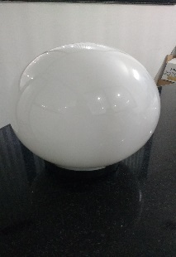 |  | Type 2 – External lights for elevation at SOB, KNM, VSC – Rs. 800/-  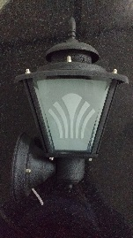 |  | Type 3 – Light above main door at Vista, BNC – Rs. 575/-  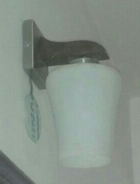
Type 4 – hanging light from ceiling for drawing, dining, balcony – Rs.600/-  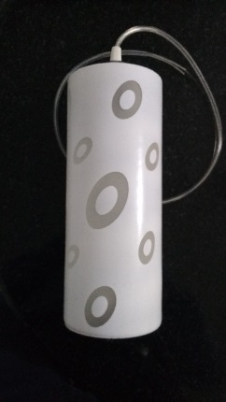 |  | Type 5 – Ceiling light for kitchen, bathroom & balcony – Rs. 600/-  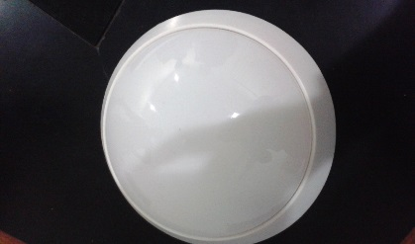 |  | Type 6 – wall light for all rooms – Rs. 600/-  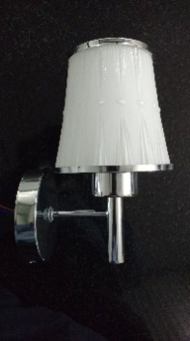
Type 7 – wall light for all rooms – Rs. 600/-  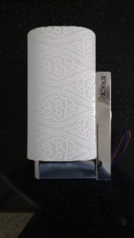 |  | Type 8 – wall light for all rooms – Rs. 600/-  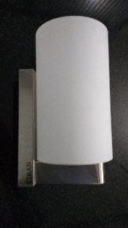 |  | Type 9 – wall light for all rooms – Rs. 600/-  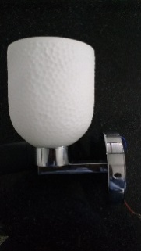
Type 10 – wall light for all rooms – Rs. 600/-  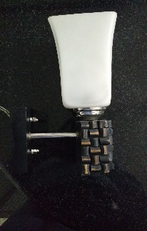 | Type 11 – wall light for all rooms – Rs. 600/-  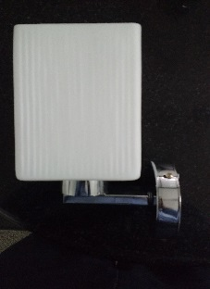 |  | Type 12 – night stand, side table lamp with shade – Rs. 460/-  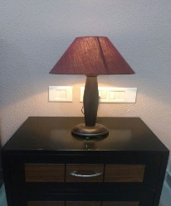 |  | Type 13-Wall Light for above washbasin -Rs.550/-  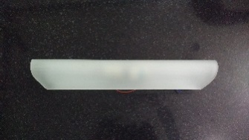

Note:
- Order wall lights for drawing, dining, bedrooms, etc., in pairs. Purchase to deliver light of types 6 to 11 depending on availability, 2 or 3 varieties for each flat/villa.
- For ceiling lights and hanging lights purchase to order closest match lights depending on availability.
- External lights, gate lights & lights over main door are finalized and cannot be changed.
- Use 5 or 7 W 2,700K LED lamps in these fittings.
- Lamps for night stands and side table for drawing room are in brown and black colour and the lamp shades colours may be chosen matching or in contrast to the colour scheme of each room. Use 3 W – 2700K LED lamps.
- Fans in kitchen should be 24” in size (Rs. 1,350/-) and fans for all other rooms are 48” 3 blade fans (Rs. 1,100/-) . Purchase is normally buying fans from Khaitan. Colours to be limited to pure white or dark brown. Do not order off white or fans with golden lines or tips.
- The above prices are indicative and may vary by +/- 15%.
- For indoor spaces within flats/villas/farms use warm light i.e., 2,700 K. for commercial areas and external lighting use white light i.e., 6,500 K. For other areas enquire before ordering warm lights/white lights.

Soham Modi

