Intl Memo no. 912/107 - Construction Date: 18.02.2019

Tiles for kitchen dado, balcony flooring, bathroom flooring, utility flooring, utility walls, swimming pool have been standardized across all sites. The details are given below. After exhausting existing stock, order the tiles listed herein. These tiles are being stocked at SSLLP.

Tile Photo | Tile name & Use | Tile Photo | Tile name & Use
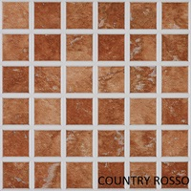 | Country Rosso  Used:  Balcony & Kitchen Dado | 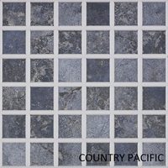 | Country Pacific Blue  Used:  Kitchen Dado
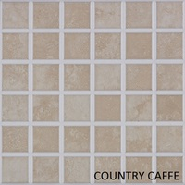 | Country Caffe  Used:  Bathroom Flooring | 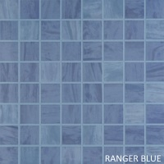 | Ranger Blue  Used:  Swimming Pool
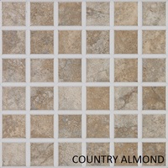 | Country Almond  Used:  Utility Flooring & Kitchen Dado | 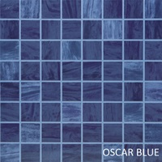 | Oscar Blue  Used:  Swimming Pool

Tile Photo | Tile name & Use | Tile Photo | Tile name & Use
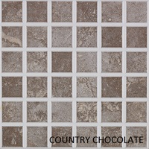 | Country Chocolate  Used:  Balcony | 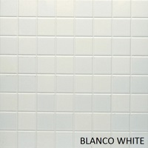 | Blanco White  Used:  Utility Walls & Kitchen Dado
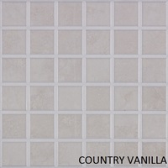 | Country Vanilla  Used:  Bathroom Flooring | 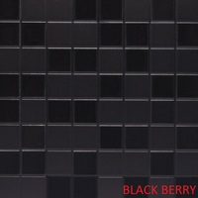 | Black Berry  Used:  Utility Flooring & Kitchen Dado
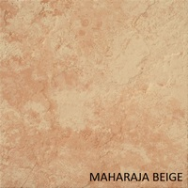 | Maharaja Beige  Used:  Kitchen Flooring | 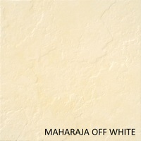 | Maharaja Off White  Used:  Kitchen Flooring

