Intl Memo no. 912/112/b - Construction Date: 16.09.2020

Subject: Guidelines for ordering equipment, tools, first aid kit, etc. for construction related works.
Keywords: Tools, equipment, toolkit/tool box, gardening tools, first aid kit

These guidelines are being issued to standardize the purchase of the following items.
- Tools and equipment.
- Tool kit/tool box for plumber and electrical.
- Gardening tools.
- Items for use of staff and security at site.
- First aid kit to be maintained at site & Medical equipment details.
A. Tools and equipment
S No. | Description | Used for | Make | Approximate cost
 | Die grinder to be used with step regulator which is used for fans like Almonard air circulator. | Finishing works near skirting, corners, near windows, etc. Can also be used for polishing of stone/granite – minor corrections only. | Powertex, PPT-DG-25 | Rs. 1,700/-
 | Die-grinder bits | For masonry grinding & leveling.  For Tinoxide polishing | NA | Rs.100 to 150/- for 5 bits
 | Angle grinder | Wall Cutting.  Leveling for installation of windows. Grinding of uneven walls.  Cutting steel rods.  Cleaning of pavers, footpath tiles, Tandoor, etc. | Bosch-GWS750 100/115/125 | Rs. 2,750/-
 | Angle grinder blades. | Masonry grinding Blade  Masonry cutting Blade  CC cutting Blade  Granite cutting Blade  Steel cutting Blade  Wire brush-Cup Wheel-100mm | Bosch-2608602797  Bosch-2608602798  Bosch-2608602798  Bosch-2608602798  Bosch-2608603412  Bosch-2608603606 | Rs.90/- per no  Rs.108/-per no  Rs.108/-per no  Rs.108/-per no  Rs.21/-per no  Rs.600/-per no
 | Sander | Sanding of walls and furniture  Buffing of windows, PVC tile corners, etc. | Bosch -  GEX 125-1 AE | Rs. 4,800/-
 | Attachment for sander | Buffing Pad  Emery Paper  Sand Paper | Polishing window and furniture. | Rs. 260/-  Rs.250/-  Rs.50/-
 | Hammer drill/ impact drill | Used for making holes in masonry& CC | Bosch - GBH 200 | Rs. 5,300/-
 | Drill bits | For masonry (3 to 10 mm set)  For wood (8, 10, 12mm -155mm length)  For metal – (6, 8, mm dia)  For metal – ( 10mm dia)  For granite and concrete (6, 8, 10, 12, 16, 20mm dia) | Bosch-2608578156  Bosch-2608587497/8/9  Adison Brand  2608680263 – 6mm – 100 mm length  2608680270 – 8mm – 100 mm length  2608680273 – 10mm – 100 mm length  2608680278 – 12mm  – 150 mm length  2608680285 – 16mm – 150 mm length  2608680290 – 20mm  – 200 mm length | Rs.350/-  Rs.100/-  Rs.105/-6MM  Rs.200/-8MM  Rs.339/-10MM  Rs.85/-  Rs.85/-  Rs.85/-  Rs.130/-  Rs.220/-  Rs.460/-
 | Earth compaction machine-  diesel engine | For compaction of earth upto 6” | Greaves ,1520 (to be substituted with electric machine) | Rs. 51,500/-
 | Welding machine –  big  small  Welding rods | Arc welding | Powertex Arc 300  Powertex Arc 200ES | Rs.14,000/-  Rs.6,500/-  Rs. 250/- per packet
 | Gas cylinder –  Acytelene  Oxygen  Pipe pair  Gas torch | Used for cutting rods or heavy steel sheets/ I sections | Local  ESAB | Rs. 13,000/-  Rs. 13,630/-  Rs. 45/- per mtr  Rs. 4,485/-
 | Lawn mover Powered | Lawn trimming | Proton 2HP | Rs. 40,880/-
 | Line laser  Tripod | Used for marking level on columns and walls. | Bosch-GLL 3-15X  Bosch BT-150 | Rs. 5,050/-  Rs. 2,655/-
 | Digital tape | To measure distances accurately | Bosch GLM 500 | Rs. 5,000/-
 | Auto leveler including  Tripod | Marking levels at site | Bosch GOL 32 D | Rs. 15,677/-
 | Kerosene torch | Used for HDPE jointing work. | Brass | Rs.1,100/-
 | Electric screw driver | Minor works at site | 06019H20RO | Rs. 2,500/-
 | Pressure Washing Machine | Washing purpose. | Kracher 150 Bar 500L/H | Rs.31,500/-
 | Floor Cleaning Machine | Used for floor cleaning purpose. | Roots E-430 | Rs. 1,13,280/-
 | Street Sweeping Machine - manual | Used for street cleaning purpose. | Roots Hako | Rs. 23,200/-
 | Chain saw | Cutting wood, felling trees, pruning | K. Power  HUSW Varna | Rs. 11,500/- 12”  Rs.26,000/- 16”
 | Clamp amp meter | Measures Current | M 266 (online purchase) | Rs.1,007/-
 | Demolition hammer  Poker  Chissle bit | Light chipping and breaking work | SHH 7200 | Rs. 14,170/-  Rs. 590/-  Rs. 590/-
 | Light meter | Measures light intensity | LX -103 (online purchase) | Rs.1,818/-
B. Tools kit/tool box for plumber & electrician
 | Spanner Set 6-32mm |  | Taparia | Rs 764/-
 | Cutting Player 8’’ |  | Taparia | Rs 246/-
 | Nose Player 6’’ |  | Taparia | Rs 215/-
 | Screw Spanner 10’’ |  | Taparia | Rs 328/-
 | Screw Driver flat 10” |  | Taparia | Rs 102/-
 | Screw Driver Philips 10” |  | Taparia | Rs. 120/-
 | Wire Stripper |  | Taparia | Rs 59/-
 | Tester 814 |  | Taparia | Rs 44/-
 | Pipe Wrench 14’’ |  | Taparia | Rs 659/-

 | Ball Pin Hammer 200 gms |  |  | Taparia |  | Rs 195/-
 | Allenkey set |  |  | Taparia |  | Rs 200/-
 | Hacksaw frame with blade 6” |  |  | Jolly |  | Rs 106/-
 | Claw hammer 450 gms |  |  | Taparia |  | Rs. 334/-
 | PVC tool box PTB-16 |  |  | Taparia |  | Rs. 950/-
C. Gardening tools
 | Axe |  |  | Tata |  | Rs.250/-
 | Spade |  |  | Tata |  | Rs.210/-
 | Shovel |  |  | Tata |  | Rs.350/-
 | Sickle |  |  | Tata |  | Rs.150/-
 | Trowel |  |  | Tata |  | Rs.40/-
 | Hand gloves |  |  | Tata |  | Rs.70/-
 | Running cutter |  |  | Tata |  | Rs. 500/-
 | Hedge cutter |  |  | Tata |  | Rs. 600/-
D. Items for use of staff and security at site
No | Description | Used for | Make |  | Approximate cost
 | Torch lights | Used for security purpose | Havells 1watt rechargeable led torch |  | Rs 260/- small  Rs 680/- Big
 | Umbrellas | Used for security purpose | Citizen |  | Rs 260
 | Safety shoes | Used for staff & security purpose | Hilison |  | Rs 400
 | Safety helmets  Staff  Male labour  Female labour | Used for staff & labour at site | Shelemet/ISI |  | Rs 175/-  Rs. 52/-  Rs. 52/-
 | Safety belts | Used for labour at site | Atlas |  | Rs 250/-
 | Rain coat | Used for staff & security purpose | Lotus |  | Rs 400/-
 | Safety jacket | Used for staff & security purpose | - |  | Rs 65/-
 | Latti | Used for security purpose | Bamboo |  | Rs 65/-
E. First aid kit & medical equipment to be used at site
 | First air kit with box  Antiseptic cream, adhesive plaster, gauze, bandage, peroxide, iodine tincture, etc.  First aid kit consumables  Cottom  Crepe Bandage  Sterile gauze dressing  Disposable gloves  Scissor  Bandages  Burnol  Hydrogen peroxide  Roller cotton bandages |  | Atlas |  | Rs. 750/-

 | Pulse Oximeter – finger type | Used for measuring oxygen level. | BPL | Rs 600/-
 | Infrared thermometer | For measuring body temperature | AICARE | Rs 900/-
 | Paracetomol -650mg | For fever |  | Rs 30/- 15 tab
 | Volini spray | For pain relief | Volini | Rs 60/- 15gm
Note:
- Above rates are inclusive GST.
- Photographs and brief description is enclosed.

Soham Modi

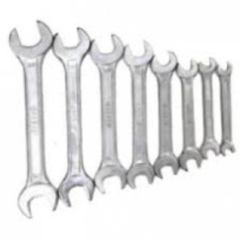  SPANNER SET | 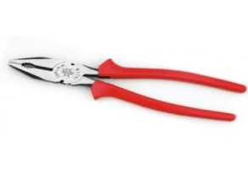CUTTING PLAYER | 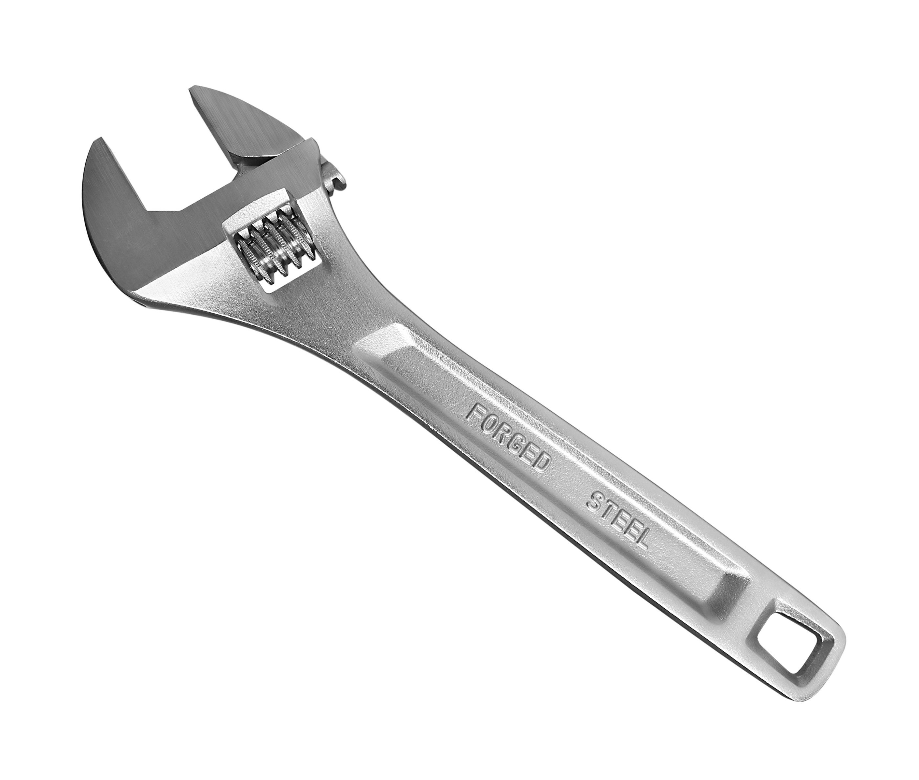  SCREW SPANNER |  | 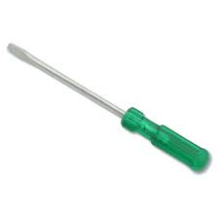  SCREW DRIVER
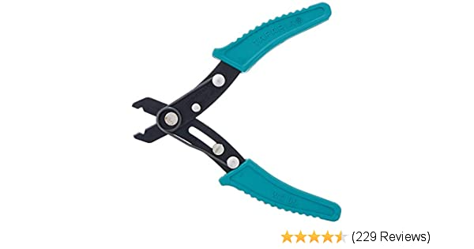  WIRE STRIPPER | 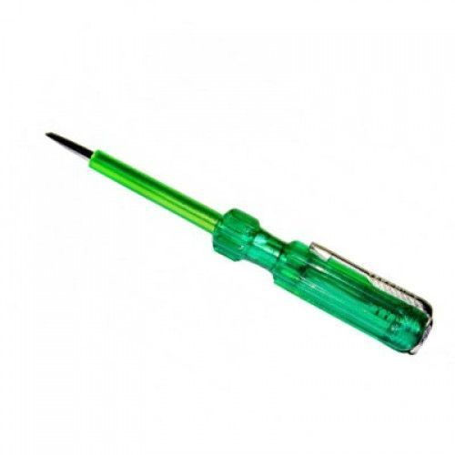  TESTER |  | 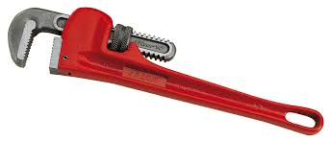  PIPE WRENCH | 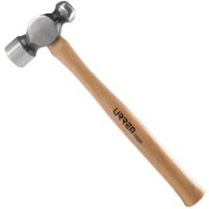  BALL PIEN HAMMER
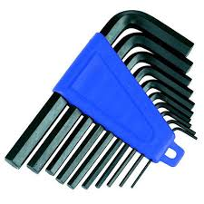  ALLENKEY SET MM | 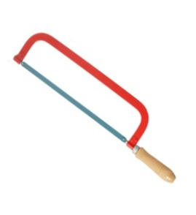  HACKSAW FRAME WITH BALDE |  | 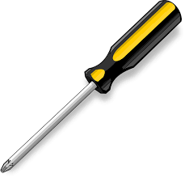  SCREW DRIVER | 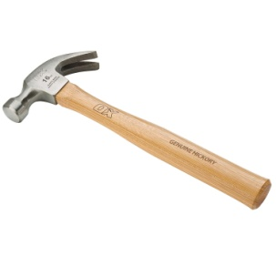 CLAW HAMMER
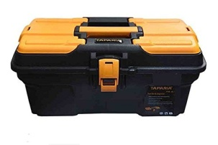  TOOL BOX | 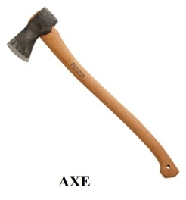 AXE |  | 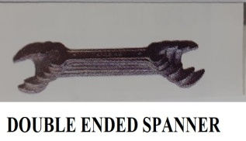 | 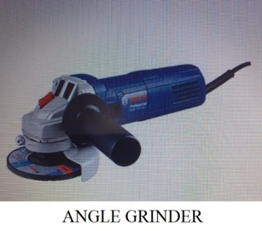
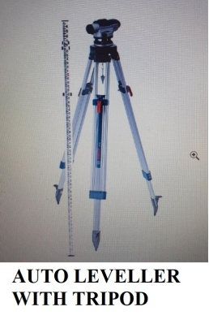 | 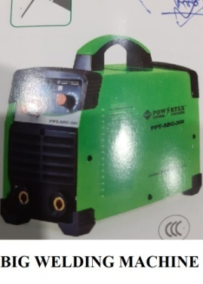 |  | 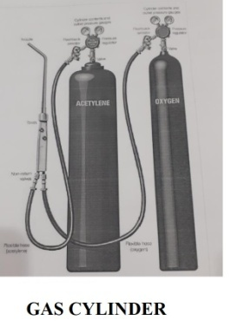 | 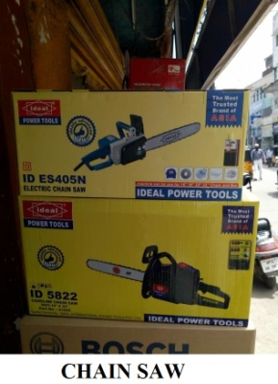
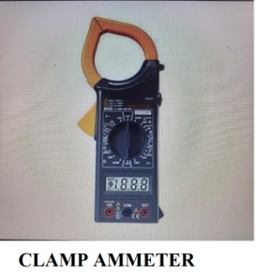 | 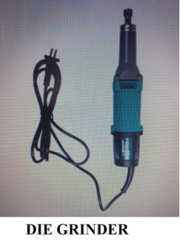 |  | 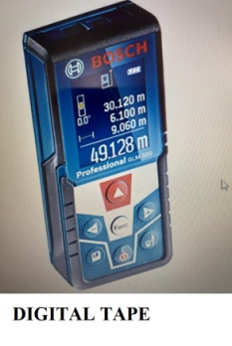 | 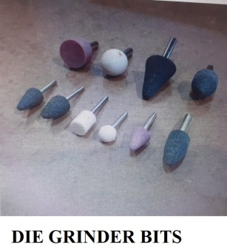
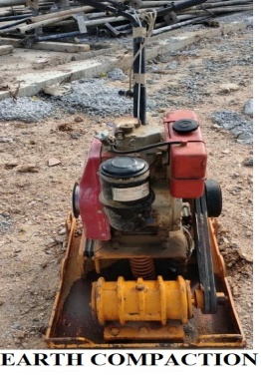 | 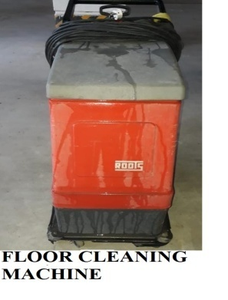 |  | 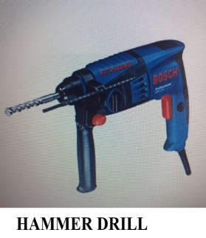 | 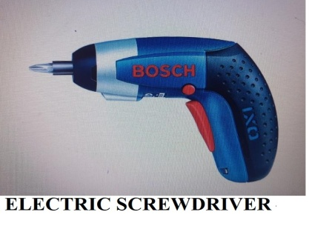
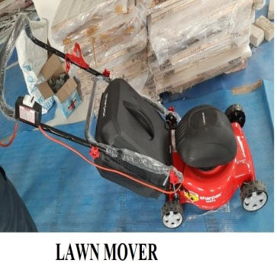 | 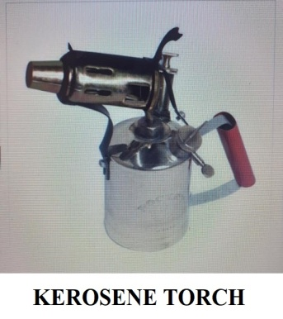 |  | 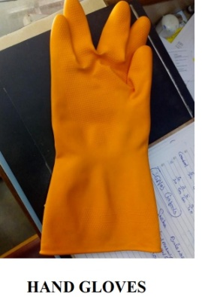 | 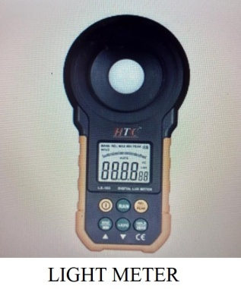
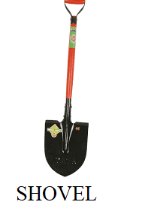 | 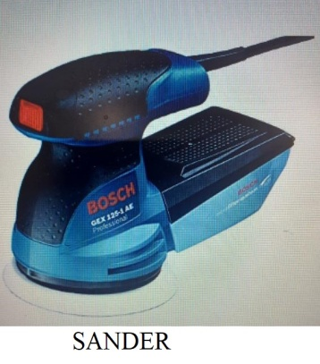 |  | 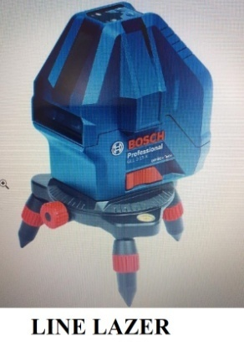 | 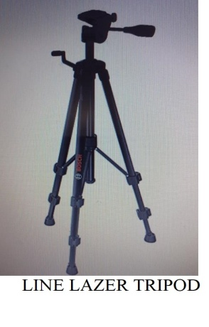
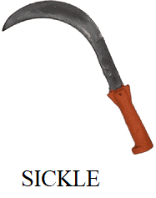 | 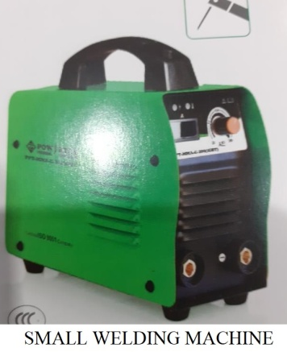 |  | 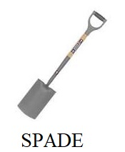 | 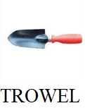
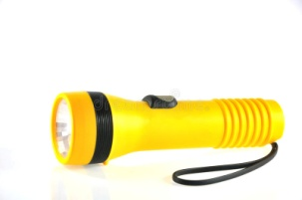  TORCH |   UMBRELLA |  | 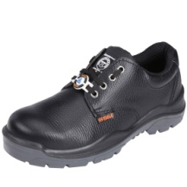  SAFETY SHOES |   SAFETY HELMET
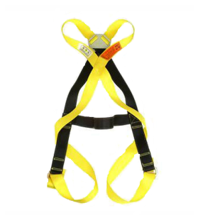  SAFETY BELT | 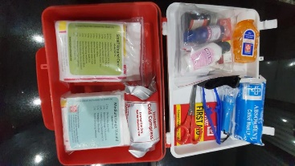  FIRST AID KIT |  | 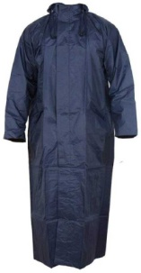  RAIN COAT | 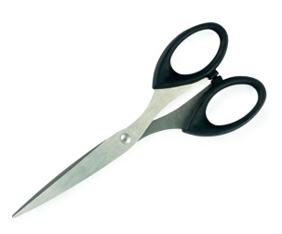  SCISSOR
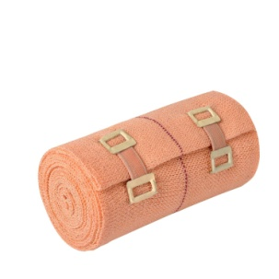  CREPE BANDAGES |  |  | 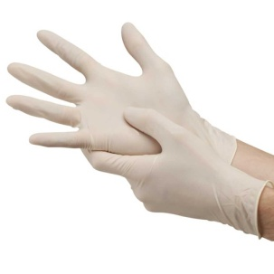  GLOVES | 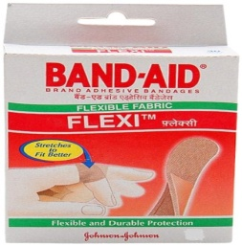  BAND-AID
  BURNOL |   HYDROGEN PEROXIDE |  | 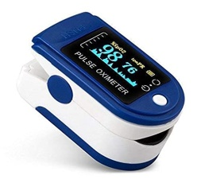  FINGERTIP PLUSE METER | 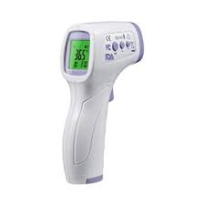  INFRARED THERMOMETER
  BANDAGES | 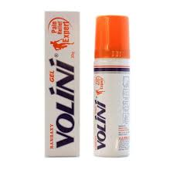  VOLINI |  |   SAFETY JACKET | 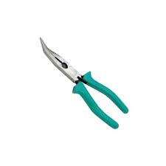  NOSE PLAYER

