|  |  |  |  |
| --- | --- | --- | --- |
| Name | Methodist Complex | | |
| Sale or Lease | Lease only | | |
| Location | Abids Main Road, Hyderabad. | | |
|  | Opposite Chermas, Next to SBH Gunfoundary. | | |
| Area | III floor: Office no. 304 – 1,445 sft | | |
| Lease | · Rs. 20 per sft | | |
|  | · Property Tax to be paid by the Lessor. | | |
|  | · 6 months rent as interest free deposit. | | |
|  | · Rent increase by 6% every year. | | |
|  | · Maintenance Rs. 2.00 per sft. | | |
|  | · | Electricity charges extra. | |
| Remarks | · Well known Shopping Complex. | | |
|  | · Ideal for banks, corporate offices, training institutes, etc. | | |
|  | · | Ample Parking. | |
|  | · Option of warm shell or plug & play at additional cost. | | |
|  |  | |  |

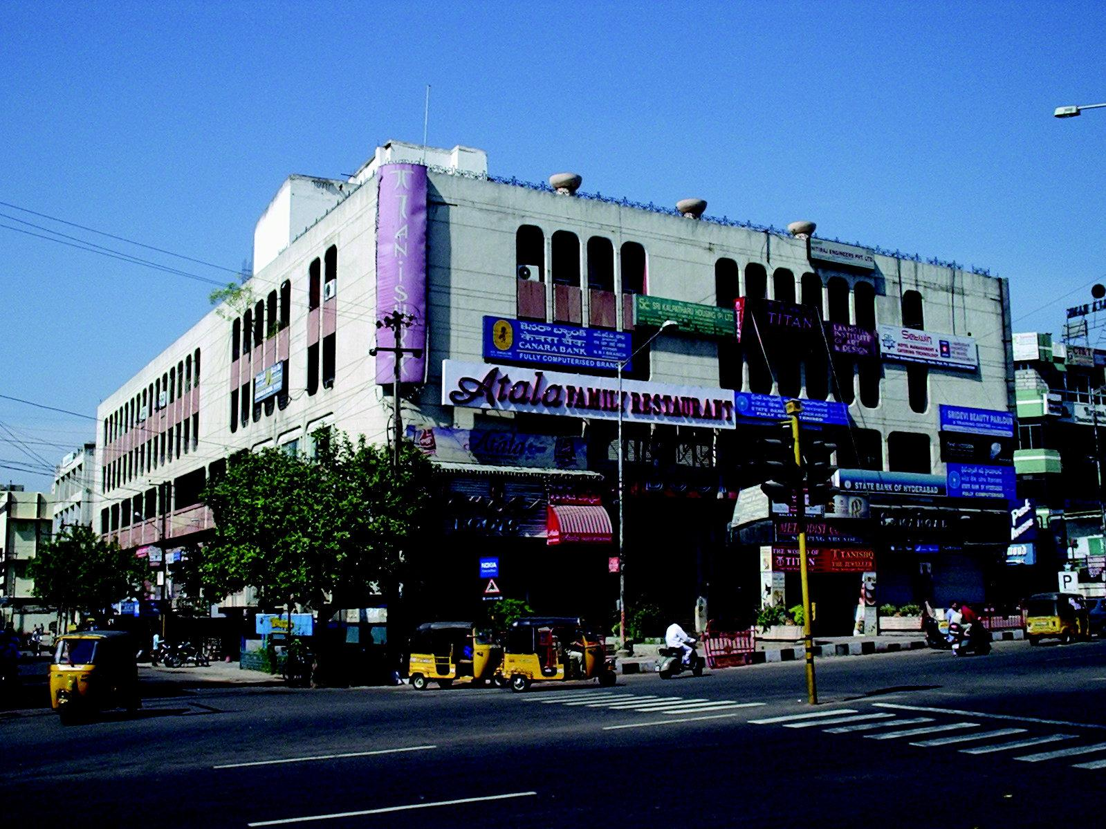

FLOOR PLAN GIVEN OVER LEAF

Modi Consultancy Services.

Call: Anand Kumar Netha +91-9502277099

Email: anandkumar@modiproperties.com, **[www.modiconsultancyservices.com](http://www.modiconsultancyservices.com/)**

Mbmc III floor writeup dt 26.06.2020

