|  |  |
| --- | --- |
| Name | Methodist Complex |
| Sale or Lease | Lease only |
| Location | Abids Main Road, Hyderabad.  Opposite Chermas, Next to SBH Gunfoundary. |
| Area | III floor: Office no. 304 – 1,445 sft |
| Lease | * Rs. 20 per sft * Property Tax to be paid by the Lessor. * 6 months rent as interest free deposit. * Rent increase by 6% every year. * Maintenance Rs. 1.50/- per sft. * Electricity charges extra. |
| Remarks | * Well known Shopping Complex. * Ideal for banquet hall, training institutes & corporate offices. * Exclusive floor. * 2 lifts * Ample Parking. |

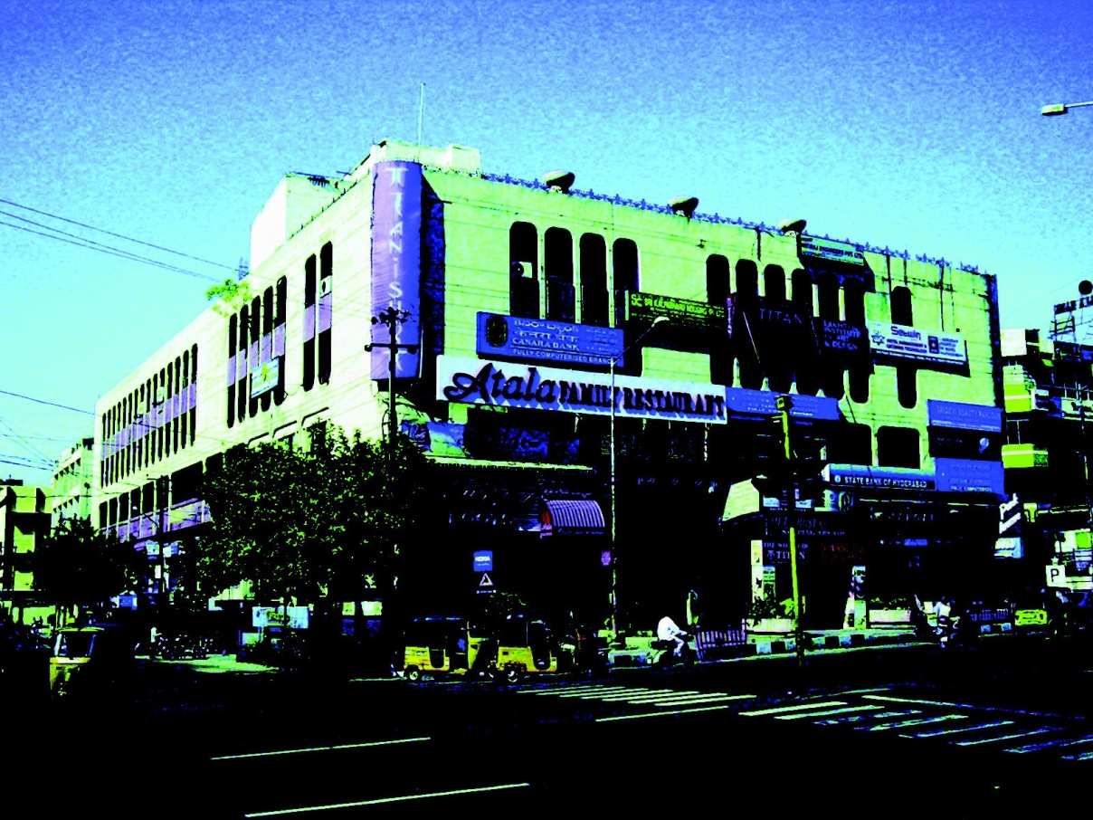

FLOOR PLAN GIVEN OVER LEAF

Modi Consultancy Services.

Call: Anand Kumar Netha +91-9502277099

Email: anandkumar@modiproperties.com, [**www.modiconsultancyservices.com**](http://www.modiconsultancyservices.com/)

Mbmc III floor writeup dt 26.06.2020

