Name | Sapphire Apartments
Sale or Lease | Sale
Location | Flat No. 205, Chikoti Gardens, Begumpet, Hyderabad.  100 mts from Begumpet Main Road.  Located in the lane next to HDFC Bank and Nalli Saris.
Area | Second Floor: 1,435 sft. (Super built-up area)
Terms for Sale | - Price – Rs. 5,500/- per sft. + car parking charges Rs. 2 lakhs.  - Payment in 60 days.  - Advance 20%.  - Maintenance charges Rs. 2,500/- per month extra.
Features | - Two bedroom, luxury apartment.  - Marble flooring.  - Design as per Vaastu.  - One car parking.  - Cabinets in kitchen & dinning; wardrobes in bedrooms.
Building – Salient Features | - Luxury apartments  - Posh quiet locality.  - Quality construction.  - Marble flooring in entire building.  - 24 hours security with EPABX.  - Recreation room.  - Only 25 flats on 2,000 sq. yds. of land.  - Children’s play ground.  - Two lifts.

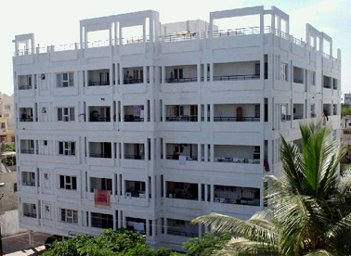

TYPICAL FLOOR PLAN GIVEN OVERLEAF

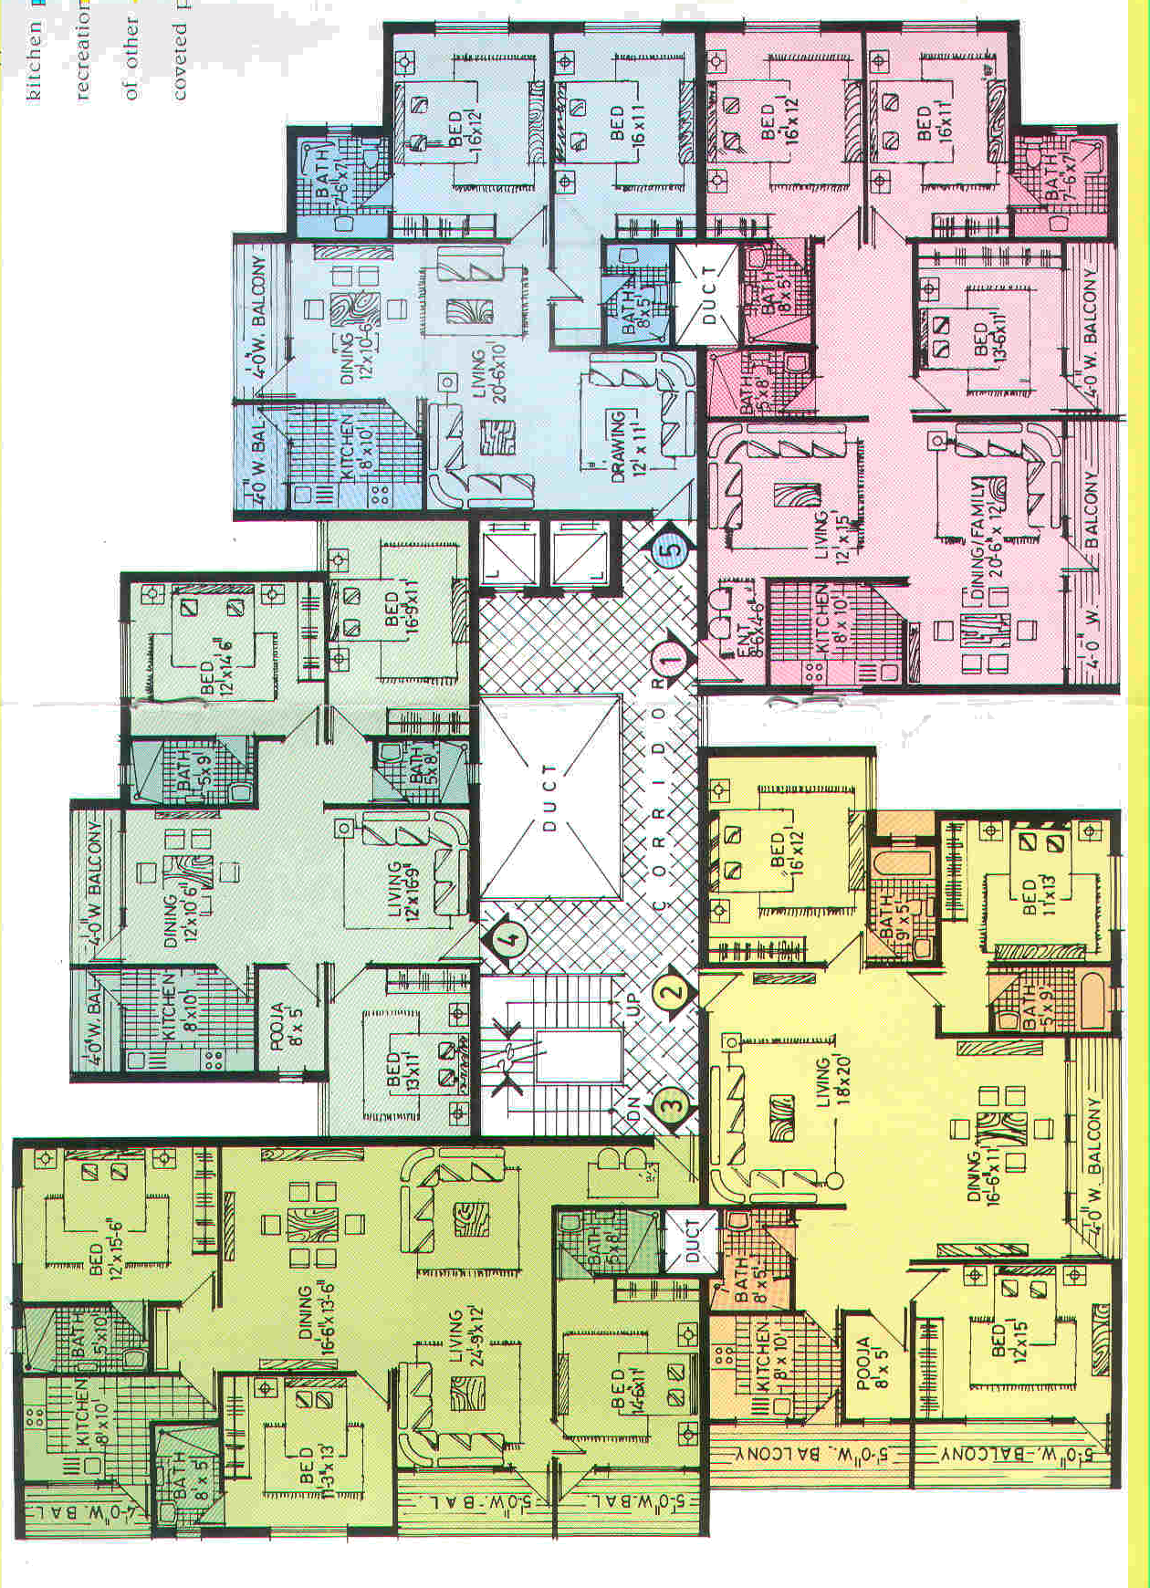
Flat No. 205
North

