|  |  |
| --- | --- |
| Name | Methodist Complex |
| Sale or Lease | Lease only |
| Location | Abids Main Road, Hyderabad.  Opposite Chermas, Next to SBH Gunfoundary. |
| Area | II floor – office no. 203 – 1,485 sft |
| Lease | * Rs. 20 per sft * Property Tax to be paid by the Lessor. * 6 months rent as interest free deposit. * Rent increase by 6% every year. * Maintenance Rs. 2.00/- per sft. * Electricity charges extra. |
| Remarks | * Well known Shopping Complex. * Ideal for banquet hall, training institutes & corporate offices. * Ample Parking. |

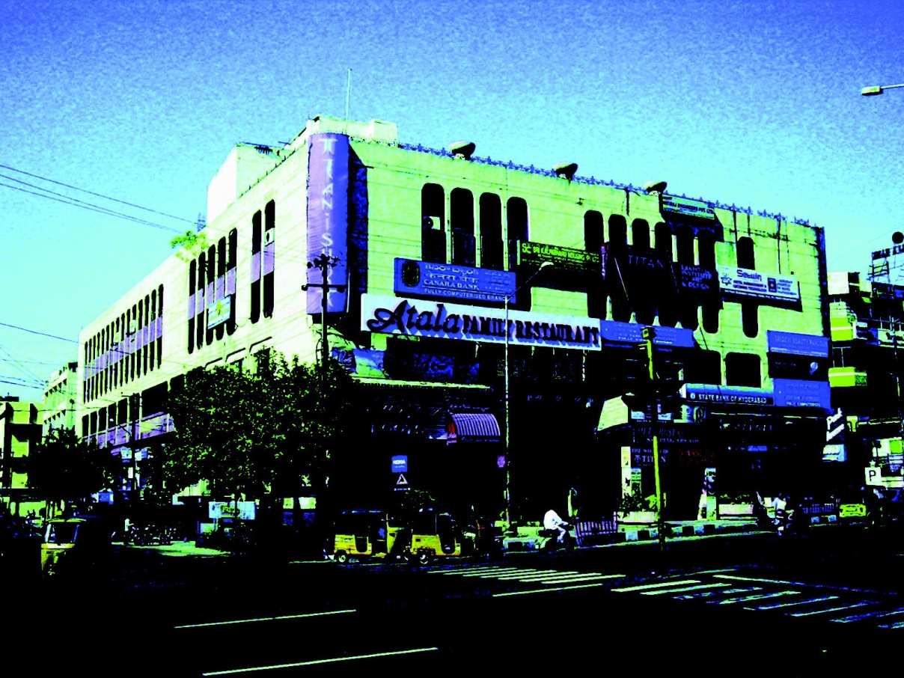

FLOOR PLAN GIVEN OVER LEAF

Modi Consultancy Services.

Call: Anand Kumar Netha +91-9502277099

Email: [anandkumar@modiproperties.com](mailto:anandkumar@modiproperties.com), www.modiconsultancyservices.com

Mbmc. II floor office rental Write up ver3 dt 26.06.2020.doc

