Intl Memo no. 912/109/A - Construction Date: 03-06-2021

Subject: Details for usage of pumps.

There are various types of pumps and sites must carefully order pumps as per recommendation in this circular. Requisition must clearly mention use of pump. Purchase must order only after correlating usage of pump mentioned in requisition with this circular.

 | SlNo | type of pump & usage | Brand/ model no. |  | Capacity | Approx. cost including of GST
 | 1 | Dewatering of pits or excavation at site – use self priming, mono-block pumps. Use green hose pipe – 5 mtrs for suction and 5 mtrs for delivery. Size of hose pipe must be equal to or slightly larger than suction/delivery of pump. Do not use foot valve. Use strainer for suction – enclose in metal box of about 18”x 18” x 18” using ¾ L angle and covered with chicken mesh. Output to be connected to properly constructed manhole. Avoid use of flat pipes. However, if flat pipes are used connect them to 5 mtr hose pipe and not to the pump. 1HP should be single phase. 3HP/5HP should be 3 phase.  Starter: L&T starter.  Cable: 7/20 service wire  MS frame: Required. Frame with handles on both sides for shifting pump | Kirloskar / Crompton |  | Typically each site should have one pump of 1HP and one pump of 3HP. Sites with lots of water may also purchase a 5HP pump. | 1HP – Rs. 12,100/-  2HP – Rs. 15,470/-  3HP – Rs. 19,200/-
 | 2 | Dewatering of large pools of water greater than 50,000 ltrs. Use submersible dewatering pump with auto on/off.  Starter: L&T starter.  Cable: 7/20 service wire  MS frame: Required. Full frame required asper standard design with mesh on all 6 sides. | Kirloskar / Crompton/KSB |  | 5HP | Rs. 26,000/-
 | 3 | Dewatering back-up pump. Diesel pump may be used. Do not use for small pits.  Starter: not applicable.  Cable: Not applicable.  MS frame: Not required. | Kirloskar |  | 3HP or 5HP | Rs. 32,000/-
 | 4 | Borewells – details of borewell pump size and no. of stages will be determined by supplier based on details given in standard requisition. Upto 1.5HP order single phase and higher capacity in 3phase.  DO NOT SPECIFY pump capacity in HP. Specify discharge i.e., 1,000 ltrs per hour for low yield, 2,000 ltrs per hour for average yield and 5,000 ltrs per hour for good yield.  Starter: Electronics starter. To be supplied by pump vendor.  Cable: L&T flat copper cable. 7/20 service wire | KSB |  | 1HP to 7.5 HP | 1.5 – Rs. 13,749/-  2 – Rs. 17,351/-  3 – Rs. 18,511/-  4 – Rs.29,045/-  5 – Rs. 22,777/-  7.5 – Rs. 41,950/-
 | 5 | Septic tank – use cutter type sewage pump  Starter: L&T starter.  Cable: L&T flat copper cable.  MS frame: Required. Full frame required asper standard design with mesh on all 6 sides. | Kirloskar |  | 1.75 to 2.5 HP | 1.75 HP – Rs. 17,700/-  2.5 HP – Rs. 22,700/-
 | 6 | Pressure booster pump – use in villas with low OHT  Starter: Not applicable.  Cable: 1 sq mm (1/18) house wiring. | Vilo |  | 0.5 to 1HP | 0.5 HP – Rs. 8,600/-
 | 7 | Sumps for water supply – use open well submersible pump. Use 3 phase pumps.  Starter: L&T starter.  Cable: L&T flat copper cable.  MS frame: Not required. | Kirloskar/ Crompton |  | 2HP to 7.5HP | 2 HP – Rs. 11,000/-  3 HP – Rs. 15,288/-  5 HP – Rs. 17,017/-  7.5 HP –
8 |  | Sumps for water supply for curing – use open well submersible pump. Single phase pump upto 1.5HP and 3 phase for higher capacity pumps.  Starter: L&T starter.  Cable: L&T flat copper cable.  MS frame: Not required. |  | Kirloskar/ Crompton | 1 to 2HP for upto 5 floors. 2 to 3 HP for 7 to 9 floors. 3 to 5 HP for 10 to 12 floors. |  | 1 HP – Rs. 11,000/-  3HP – Rs. 15,288/-  5HP – Rs. 17,360/-
9 |  | Curing using plastic tanks of 500 to 1,000 ltr capacity (for some villa projects). Use single phase mono-block pumps.  Starter: L&T starter - optional.  Cable: 3/20 service wire. |  | Kirloskar/ Crompton | ½ HP to 1HP. |  | 0.5HP – Rs. 2,350/-  1HP – Rs. 4,008/-

Notes:
- Pump should be ordered along with rest of fittings like flanges, bends, GI fittings, nipples, nozzle, valve, union, plug, pipes, starters. MS frame, etc.
- For borewells use HDPE pipes.
- Photographs of 7 types of pumps is enclosed as Annexure -A.

Soham Modi.
Annexure -A
Internal memo no. 912/109/A -Details for usage of pumps
Photos of 7 types of pumps

Self priming dewatering pump | Open well submersible pump | Mono block pump
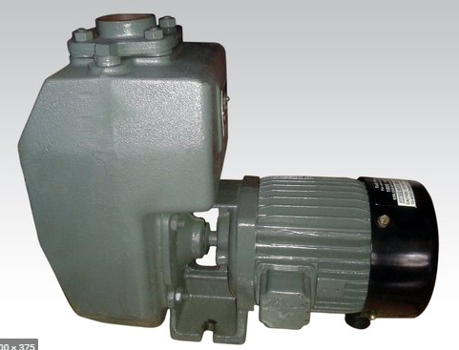 | 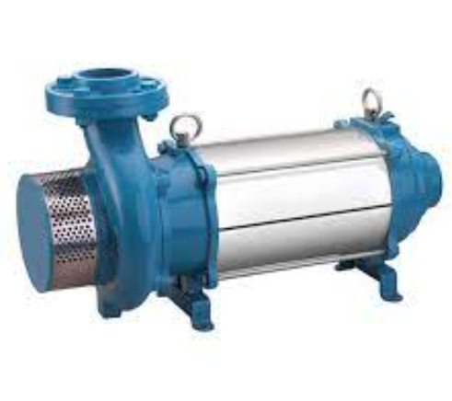 | 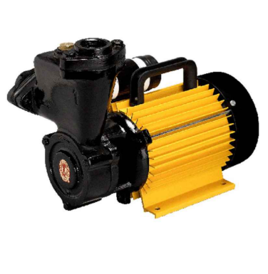
Borewell pump | Cutter type sewage pump | Pressure booster pump
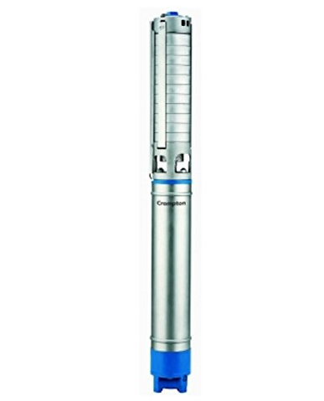 | 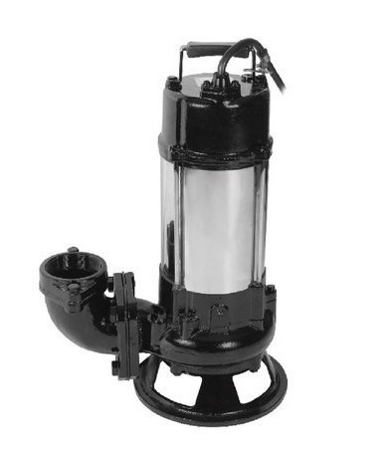 | 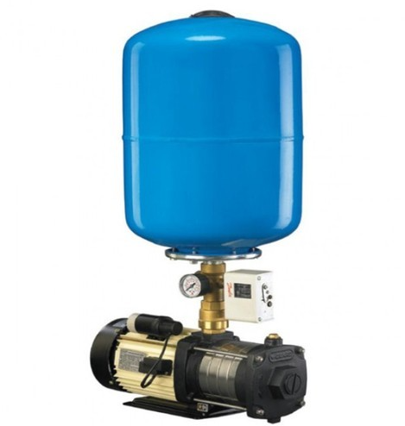
Diesel pump | MS frame for self priming pump | MS frame for cutter type sewage pump
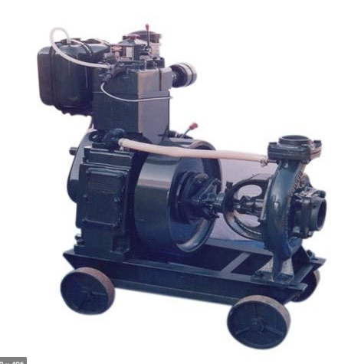 | 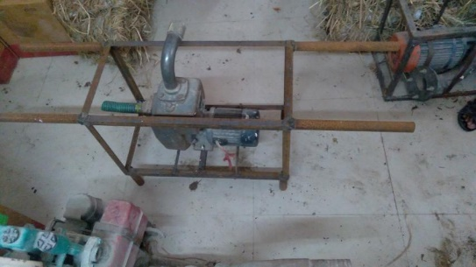 | 