Internal memo no. 912/151- Const Date: 05-08-2023

Subject: Highlighted colours for model flats and villas.
Key words: Highlighted colour, Model flats, Model villas.

Standard colours for highlighted walls are been specified herein. 2 walls in each room opposite the entrance floor shall be painted with these colours. Bedsheets, rugs & curtains to be matched with these colours. The colour codes are from Asian paint catalogue. On a later date standard design for curtains, rugs & bedsheets will be specified.

For now these are applicable to the model villas at SOV, NE & AGH.

The scanned colour code palette is attached herein. However, it is only indicative. Original palette must be referred to for the exact colour.

Colour no.1 – Living & Dining
Option 1 – Sands of time – 4202
Option 2 – Warm stone – 0N02

Colour no. 2 – Ground floor guest bedroom in villas
Option 1 – Burnished earth -9929.
Option 2 - Caramel custard – 8534

Colour no. 3 – 1st floor lounge – only for villas. Drawing room in flats
Option 1 – Dash of purple – 7160
Option 2 – Silver grey – 0615

Colour no. 4 - Master bedroom – 1st floor in villas
Option 1 - Strawberry – 0481.
Ooton 2 – Tinge of pink – 8066.

Colour no. 5 – Children bedroom – 1st floor in villas.
Option 1 – Orange Tango – X113
Option 2 - Fire globe – 7950

Soham Modi.

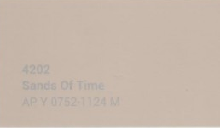  Sans of time - 4202 | 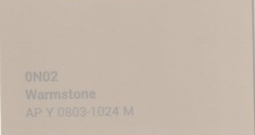  Warm stone – 0N02
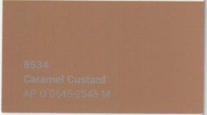  Caramel Custard - 8534 | 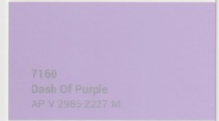  Dash of Purple – 7160
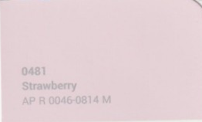  Strawberry - 0481 | 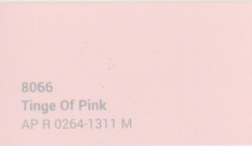  Tinge of pink – 8066
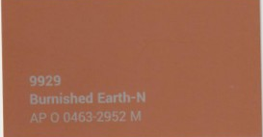  Burnished earth - 9929 | 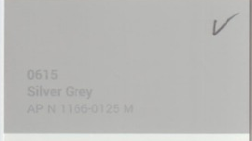  Silver grey – 0615
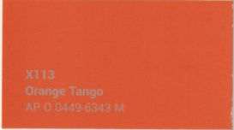  Orange Tango – X113 | 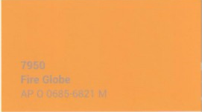  Fire globe - 7950

