Internal memo no. 912-160 - construction division Date: 07-09-2023

Subject: Streetlight poles and footing details.
Keywords: streetlight, poles, footing

- Purchase and installation of streetlights have been standardised. The details are given herein.
- Octagonal GI poles telescopic to be used for streetlights, general lighting, security cameras, etc. Pole sizes and SKU
- 5 mtr poles to be used for general lighting in housing projects – SKU ELEC5918-Electrical-Octagonal GI poles-5000mm-Nos.
- 6mtrs poles to be used for general lighting in lab space projects – SKU ELEC3750-Electrical-Octagonal GI poles-6000mm-Nos.
- 9mtrs poles to be selectively used for high mask lighting – SKU ELEC5244-Electrical-Octagonal GI poles-9000mm-Nos.
- Poles of other heights to be ordered only if specified by Soham/consultant- SKU ELEC2758-Electrical-Octagonal GI poles-4000mm-Nos, ELEC5037-Electrical-Octagonal GI poles-4500mm-Nos, ELEC6537-Electrical-Octagonal GI poles-7000mm-Nos.
- Do not order MS poles or other types of poles, unless specified by Soham or consultant (SKU for MS pole of miscellaneous height - ELEC6195-Electrical-MS Street pole -MISC - Nos).
- GI poles must be ordered with 4 nos 300mm x 16mm J type foundation bolts (SKU HARD8670-Hardware-MS J Bolt-kgs). Each bolt should have 3 nuts and washers (2mm).
- For poles upto 6mtrs in height – footing size should be 600x600x300mm, footing pedestal should be atleast 600mm x 300mm x 300mm. Mat should be with 10mm tor at the rate of 150mm. column steel should be 4 rods of 12mm with 8mm stirrups @ 100mm. Maximum depth of pedestal should not exceed 1200mm.
- For poles longer than 6mtrs in height or if footing depth is more than 1500mm – footing size should be 900x900x300mm, footing pedestal should be atleast 600mm x 300mm x 300mm. Mat should be with 10mm tor at the rate of 150mm. column steel should be 4 rods of 16mm with 8mm stirrups @ 100mm. Maximum depth of pedestal should not exceed 2500mm.
- M20 concrete may be used. If required, lay 100mm PCC.
- Shear force is more important for these footings compared to soil bearing capacity. Therefore, layer wise compaction upto a radius of 1mtr with stamping rod is mandatory.
- The pedestal should be 100mm above the finished floor level of footpaths, driveways, lawns, etc. This is to avoid rusting of the foundation bolts.
- Foundation bolts must be fixed above and below the base plate of the poles. This is required for levelling. 12mm plywood template must be used at the time of fixing foundation bolts to RCC pedestal.
- Arms for the poles:
- Long arm – 900 to 1200mm – SKU ELEC5478-Electrical-Octagonal GI pole side arm-Long arm-Nos.
- Short arm upto 600mm – SKU ELEC5977-Electrical-Octagonal GI pole side arm-Short arm-Nos.
- Double arm – long – SKU ELEC3207-Electrical-Street light arm-Double arm -Long-Nos.
- Double arm – short – SKU ELEC1339-Electrical-Street light arm-Double arm -Short-Nos.
- 900mm ring – SKU ELEC5549-Electrical-Octagonal GI pole ring-900mm-Nos.
- Photographs of the items are attached herein.
- Types of LED lights to be used are separately specified in an other internal memo.
ELEC5918-Electrical-Octagonal GI poles-5000mm-Nos.  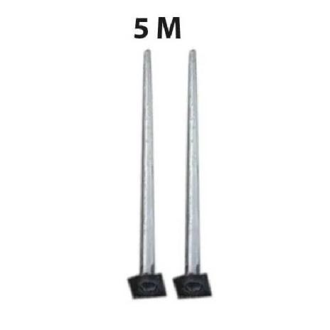 | ELEC3750-Electrical-Octagonal GI poles-6000mm-Nos.  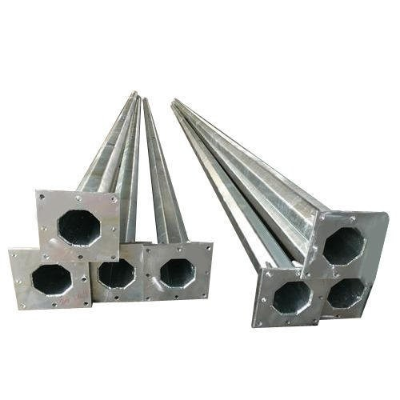
ELEC5244-Electrical-Octagonal GI poles-9000mm-Nos.  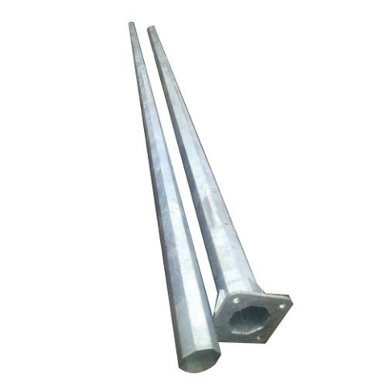 | HARD8670-Hardware-MS J Bolt- kgs  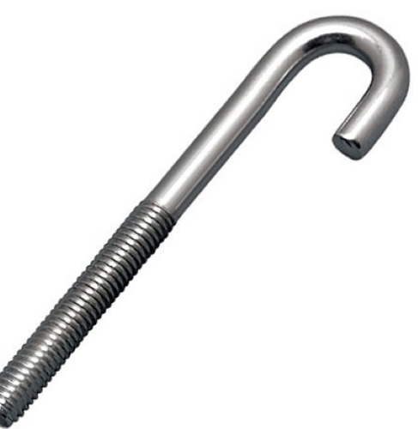
ELEC3207-Electrical-Street light arm-Double arm -Long-Nos.  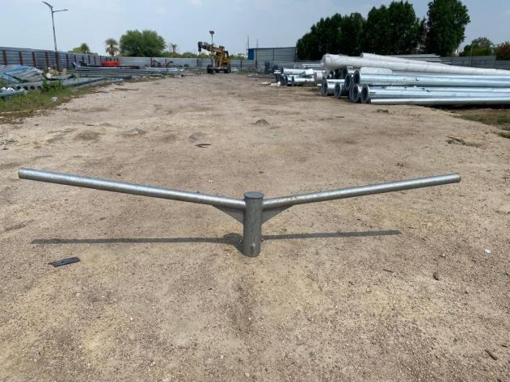 | ELEC5478-Electrical-Octagonal GI pole side arm-Long arm-Nos.  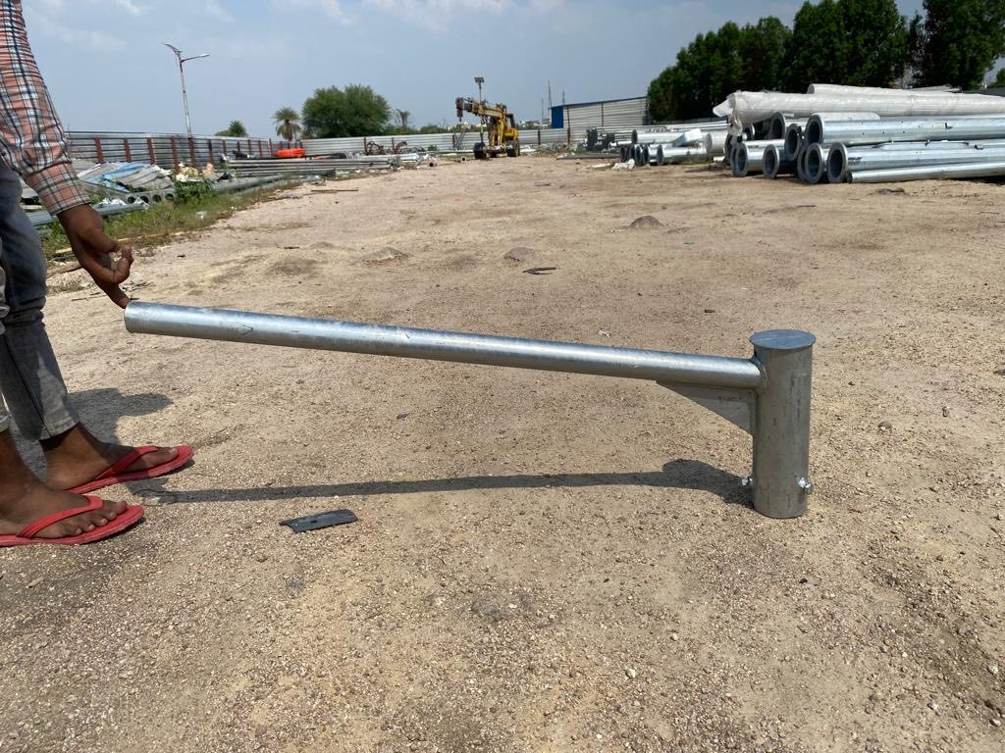
ELEC5549-Electrical-Octagonal GI pole ring-900mm
