Intl Memo no. 912/109/B - Construction Date: 01-03-2024

Subject: Details for usage of pumps.
Key words: Pumps, Starters.

- There are various types of pumps and sites must carefully order pumps as per recommendation in this circular. Requisition must clearly mention use of pump. Purchase must order only after correlating usage of pump mentioned in requisition with this circular. Purchase to consult MEP in case of any doubts.
- Dewatering pumps:
  - Dewatering of pits or excavation at site – use self priming, mono-block pumps.
  - Use green hose pipe – 5 mtrs for suction and 5 mtrs for delivery. Size of hose pipe must be equal to or slightly larger than suction/delivery of pump. Do not use foot valve.
  - Use strainer for suction – enclose in MS box (fabricated) of about 18”x 18” x 18” using ¾ L angle and covered with chicken mesh.
  - Output to be connected to properly constructed manhole.
  - Avoid use of flat pipes (canvas flat pipes are preferred over PVC flat pipes). However, if flat pipes are used, connect them to 5 mtr hose pipe and not to the pump.
  - 1HP should be single phase. 3HP/5HP should be 3 phase.
  - Use manual starter of L&T.
  - Use aluminum service wire 2.5 sqm upto 2HP pumps (SKU no. ELEC8024). Use aluminum service wire 4 sqm above 2HP pumps (SKU no. ELEC1392).
- CI - Cutter type dewatering pumps:
  - Use cutter CI pumps for septic tank and mud sumps.
  - Do not use for dewatering in construction activity.
  - Use 1.75HP in most cases. In case backup pump is being used install 1.75 HP with 2.50 HP pump.
  - These pumps do not require starters.
  - They must be kept on 24/7. Directly connect to panel.
  - Use 2.5/4 sqmm 2 core flat copper cable (SKU no. __ & __ ) for 1.75 & 2.75 HP respectively.
- SS - Cutter type dewatering pumps:
  - Use SS cutter pump for dewatering of very small size mud sumps.
  - Do not use for dewatering in construction activity.
  - Use 0.75HP pump.
  - These pumps do not require starters.
  - They must be kept on 24/7. Directly connect to panel.
  - Use 2.5 sqm 3 core flat copper cable (SKU no. ELEC4585).
- Diesel Dewatering back-up pump:
  - Use diesel pump.
  - Do not use for small pits.
  - Pump capacity of 3HP & 5HP can be used.
- Dewatering of large pools of water greater than 50,000 ltrs.
  - Use cutter type CI dewatering pump with auto on/off.
  - Specifications shall be based on site conditions.
  - MS frame required. Full frame required asper standard design with mesh on all 6 sides.
- Borewell pumps:
  - Details of borewell pump size and no. of stages will be determined by supplier based on requirement given by site. Fill form attached as Annx A herein (the form has been uploaded in staff login page under purchase division).
  - MEP/purchase to discuss with supplier and determine the pump required. Details of starter, cable and fitting shall also be specified by MEP.
  - However, the following pumps to be standardized:
    - Head 10m– discharge 1-3 kl/hr. Single phase.
    - Head 30m – discharge 2-6kl/hr. Single phase.
    - Head 100m – discharge 2-6kl/hr. 3 phase.
    - Head 150m – discharge 2-6kl/hr. 3 phase.
- Pressure booster pump:
  - Use in villas with low OHT. 0.5HP.
  - Starter not required.
  - Connect with 1.5sqm copper cable.
- Open well submersible pumps:
  - Several types of pumps are to be used as follows:
  - 1HP, single phase, use 2 core 2.5sq mm flat cable (SKU __). Use for curing of villas for small sumps. Also use for common area works at ground level.
  - 2HP, single phase, use 2 core 2.5sq mm flat cable (SKU __). Use for curing of apartment blocks of less than 18 m height. Use single phase where power supply is poor.
  - 2HP, 3phase, use 2.5sqmm 3 core flat cable. Use for curing of apartment blocks of less than 18 m height.
  - 3HP, 3phase, use 2.5sqmm 3 core flat cable. Use for curing of apartment blocks/ lab space buildings between 18 to 24 m height. Also use for water supply from sump to OHT in buildings less than 18m in height.
  - 5HP, 3phase, use 4sqmm 3 core flat cable. Use for curing of apartment blocks / lab space buildings more than 24 m in height.
  - 2HP, 3HP, 5HP, 7.5HP multi stage horizontal pumps to be used for water supply from sump to OHT for buildings of height more than 18 mtrs. MEP to decide type of pump to be used.
- Mono block pump:
  - These are to be used for curing of buildings not more than 7m in height.
  - Use 0.5HP or 1HP pumps.
  - Connect to 1000 or 2000 ltr PVC tanks.
  - These require single phase starters. Use sparingly.

Sl. No. | Type of pump | Brand & model no. | SKU no | Approx. cost including GST in Rs.
 | Dewatering – self priming – monoblock – 1HP – single phase | ?? | PLUM8711 | ??
 | Dewatering – self priming – monoblock – 2HP – 3 phase | Kirloskar – SP1HM | PLUM2237 | 9,468/-
 | Dewatering – self priming – monoblock – 3HP – 3 phase | Kirloskar – SP2HM | PLUM8991 | 12,196/-
 | Dewatering – self priming – monoblock – 5HP – 3 phase | ?? | PLUM7959 | ??
 | DOL Starter – single phase - manual – upto 6A | ?? | ?? | ??
 | DOL Starter – 3 phase - manual – upto 6A | ?? | ?? | ??
 | DOL Starter – 3 phase - manual – upto 6 to 12A | ?? | ?? | ??
 | DOL automatic Starter – single phase pump with dry run protection – 1 to 2 HP | ?? | ?? | ??
 | Star Delta automatic Starter – 3 phase pump with dry run protection – 2 to 3HP | ?? | ?? | ??
 | Star Delta automatic Starter – 3 phase pump with dry run protection – 5 HP | ?? | ?? | ??
 | Dewatering cutter type pump – SS – single phase | Kirloskar – 750Sw | ?? | ??
 | Dewatering cutter type CI pump 1.75HP – single phase | Kirloskar -1300Bw | PLUM5131 | 33,837/-
 | Dewatering cutter type CI pump 2.5HP – single phase | Kirloskar - Eterna 1800bw 2.5 | PLUM8358 | 37,288/-
 | Diesel dewatering pump – 3HP | ?? | PLUM7458 | ??
 | Diesel dewatering pump – 5HP | ?? | PLUM 2682 | ??
 | Borewell pump – 4” – head 10m – single phase | ?? | ?? | ??
 | Borewell pump – 4” – head 30m – 3phase | ?? | ?? | ??
 | Borewell pump – 4” – head 100m – 3 phase | ?? | ?? | ??
 | Borewell pump – 4” – head 150m – 3 phase | ?? | ?? | ??
 | Pressure booster pump | Kirloskar KDS 1348-12.5hp | FIRE1752 | 55,513/-
 | Open well submersible pump – 1HP – 1 phase | Kirloskar-KOSI 135 | PLUM3455 | 13900/-
 | Open well submersible pump – 2HP – 1 phase | Kirloskar-KOSI-225 | ?? | 18900/-
 | Open well submersible pump – 2HP – 3 phase | Kirloskar-KOS-235M | PLUM1340 | 23900/-
 | Open well submersible pump – 3HP – 3 phase | Kirloskar-KOSI 335 | PLUM4290 | 26900/-  -
 | Open well submersible pump – 5HP – 3 phase |  | PLUM6028 | 29900/-
 | Open well submersible pump – multi stage - 2HP – 3 phase | LUBI – 58A | ?? | ??
 | Open well submersible pump – multi stage - 3HP – 3 phase | LUBI – 1B | ?? | ??
 | Open well submersible pump – multi stage – 5HP – 3 phase | ?? | ?? | ??
 | Open well submersible pump – multi stage – 7.5HP – 3 phase | ?? | ?? | ??

Notes:
- Do not use elbows. Only use long bends.
- Pumps that are brunt out and need rewinding can be purchased by SSLLP/Tatva Agencies at 40% of present price of the pump inclusive of GST.
- Old repaired pumps can be resold to respective projects at 60% of present price of pump.
- Old pumps that are not repairable to be sent to SSLLP/Tatva Agencies free of cost – SSLLP to cannibalize these pumps for repairing older pumps. They may be scrapped only if they cannot be used for spares.
- Sites to send old pumps for repair to SSLLP/Tatva Agencies and SSLLP/Tatva Agencies to immediately give replacement of repaired pumps in exchange for pump that needs repair. Procedure for requisition, PO, gate pass/E Way bill (for buy back and replacement) to be strictly followed.
- SSLLP/Tatva Agencies to maintain stock of MS stand/cage in sufficient numbers.
- Stock of following fittings to be maintained.
- Green hose pipe – 25mm, 32mm, 40mm & 63mm.
- GI nozzles – 25mm, 32mm & 40mm. min. stock – 5 nos each.
- Hose clips – 100 nos.
- GI nipples, long bend, reducer T (to 20mm), couplers, unions, gate valve, plug – for sizes 20, 25, 32 & 40. min. stock 10 nos each
- NRV – for sizes 20, 25, 32 & 40. min. stock 2 nos each.
- Strainer for hose pipe – 2 nos each.
- Manual starters – 3 nos each.
- Flat cable (standard size – excluding borewells).
- Internal memo no. 912/163 stands cancelled.

Soham Modi.

Annexure -A
Internal memo no. 912/109/B - MEP authorization for ordering pumps
Company name:
Site & block no.
Brief description of purpose:
Type of pump required:
SKU, if available (refer to relevant internal memo):
Material required by date:
In case of borewell specify borewell depth, pump installation depth, horizontal distance for delivery, vertical distance for delivery:
In case of replacement of borewell specify size of existing HDPE pipe:
Discharge required (in LPS or LPH):
Sl no. | Sub-category | Item/SKU |  |  | Size | Units |  | Specs/make | Quantity required
 | Pump
 | Starter
 | Cable
 | HDPE pipe in borewell
 | Pipe for horizontal travel
 | Pipe for vertical travel
 | Coupler
 | Ball valve
 | NRV
 | Bends
 | Nipples
 | Valves
 | MS stand
Remarks:
Prepared/approved by: |  |  | Site in-charge | MEP |  |  | Director
Name
Sign
Date
Note: 1. Sites to send fully filled sheets to MEP in word format. 2. MEP to correct requirements and return it to site – signed scanned copy on viber.3. Sites must get this authorization before they make requisition.
Annexure - B
Internal memo no. 912/109/B - Details of pumps
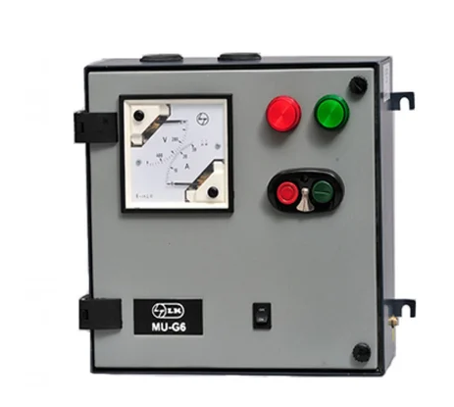  Manual Starter – ELEC8691 | 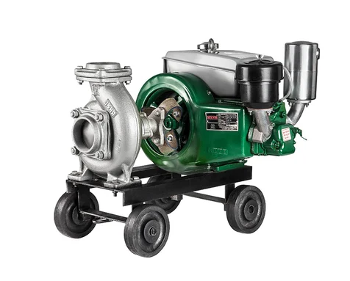  Diesel dewatering pump -
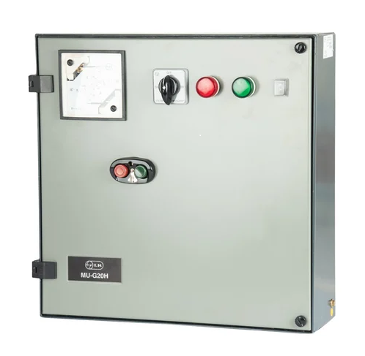  Automatic starter – ELEC9005 | 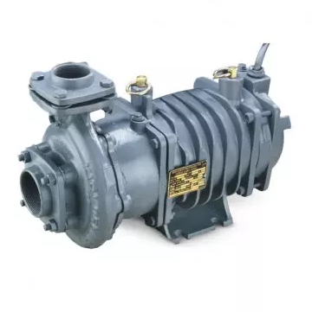  Open well submersible pump - PLUM3455
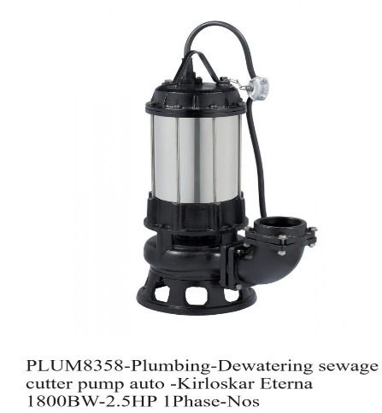 | 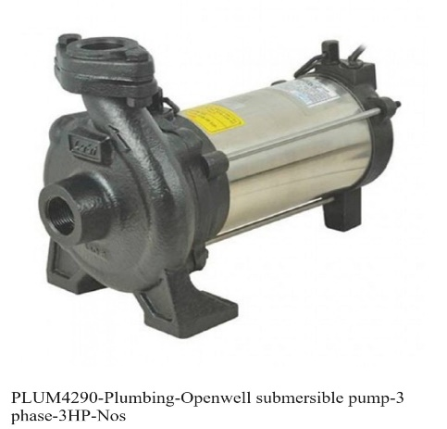
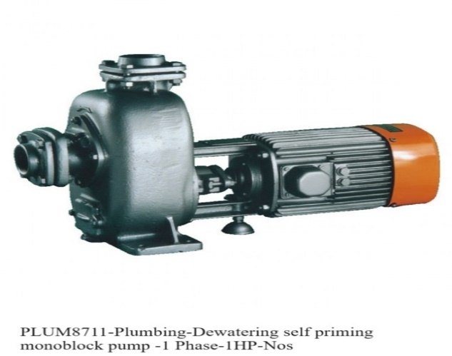 | 