Intl Memo no. 912/109/B - Construction Date: 22-03-2024

Subject: Details for usage of pumps.
Key words: Pumps, Starters.

- There are various types of pumps and sites must carefully order pumps as per recommendation in this circular. Requisition must clearly mention use of pump. Purchase must order only after correlating usage of pump mentioned in requisition with this circular. Purchase to consult MEP in case of any doubts.
- Dewatering pumps:
  - Dewatering of pits or excavation at site – use self priming, mono-block pumps.
  - Use green hose pipe – 5 mtrs for suction and 5 mtrs for delivery. Size of hose pipe must be equal to or slightly larger than suction/delivery of pump. Do not use foot valve.
  - Use strainer for suction – enclose in MS box (fabricated) of about 18”x 18” x 18” using ¾ L angle and covered with chicken mesh.
  - Output to be connected to properly constructed manhole.
  - Avoid use of flat pipes (canvas flat pipes are preferred over PVC flat pipes). However, if flat pipes are used, connect them to 5 mtr hose pipe and not to the pump.
  - Use manual starter of L&T.
  - Use aluminum service wire 2.5 sqm upto 2HP pumps (SKU no. ELEC8024). Use aluminum service wire 4 sqm above 2HP pumps (SKU no. ELEC1392).
- CI - Cutter type dewatering pumps:
  - Use cutter CI pumps for septic tank and mud sumps.
  - Do not use for dewatering in construction activity.
  - Use 1.75HP in most cases. In case backup pump is being used install 1.75 HP with 2.50 HP pump.
  - These pumps do not require starters.
  - They must be kept on 24/7. Directly connect to panel.
  - Use 2.5/4 sqmm 3 core flat copper cable (SKU no. 4585 & 9885) for 1.75 & 2.75 HP respectively.
  - MS frame required. Full frame required asper standard design with mesh on all 6 sides.
- SS - Cutter type dewatering pumps:
  - Use SS cutter pump for dewatering of very small size mud sumps.
  - Do not use for dewatering in construction activity.
  - Use 0.75HP pump.
  - These pumps do not require starters.
  - They must be kept on 24/7. Directly connect to panel.
  - Use 2.5 sqm 3 core flat copper cable (SKU no. ELEC4585).
- Diesel Dewatering back-up pump:
  - Use diesel pump.
  - Do not use for small pits.
  - Pump capacity of 4HP can be used.
  - Discharge about 32kl per hour.
  - Suction and delivery – 80mm.
- Dewatering of large pools of clear water greater than 50,000 ltrs.
  - Use cutter type CI dewatering pump with auto on/off.
  - Specifications shall be based on site conditions.
  - MS frame required. Full frame required asper standard design with mesh on all 6 sides.

- Borewell pumps:
  - Details of borewell pump size and no. of stages will be determined by supplier based on requirement given by site. Fill form attached as Annx A herein (the form has been uploaded in staff login page under purchase division).
  - MEP/purchase to discuss with supplier and determine the pump required. Details of starter, cable and fitting shall also be specified by MEP.
  - However, the following pumps to be standardized:
    - Head 10m– discharge 2-3 kl/hr. Single phase.
    - Head 30m – discharge 3-4kl/hr. Single phase.
    - Head 100m – discharge 3-4kl/hr. 3 phase.
    - Head 150m – discharge 4-6kl/hr. 3 phase.
- Pressure booster pump:
  - Use in villas with low OHT. 0.5HP.
  - Starter not required.
  - Connect with 1.5sqm copper cable.
- Open well submersible pumps:
  - Several types of pumps are to be used as follows:
  - 1HP, single phase, use 3 core 2.5sq mm flat cable (SKU 4585). Use for curing of villas for small sumps. Also use for common area works at ground level.
  - 2HP, single phase, use 3 core 2.5sq mm flat cable (SKU 4585). Use for curing of apartment blocks of less than 18 m height. Use single phase where power supply is poor.
  - 2HP, 3phase, use 2.5sqmm 3 core flat cable. Use for curing of apartment blocks of less than 18 m height.
  - 3HP, 3phase, use 2.5sqmm 3 core flat cable. Use for curing of apartment blocks/ lab space buildings between 18 to 24 m height. Also use for water supply from sump to OHT in buildings less than 18m in height.
  - 5HP, 3phase, use 4sqmm 3 core flat cable. Use for curing of apartment blocks / lab space buildings more than 24 m in height.
  - 2HP, 3HP, 5HP, 7.5HP multi stage horizontal pumps to be used for water supply from sump to OHT for buildings of height more than 18 mtrs. MEP to decide type of pump to be used. However, two pumps have been standardized. 4HP pump to be used for buildings upto 30mtrs height (discharge 10kl per hour) and 6HP pump to be used upto 42mtrs height (discharge 12kl per hour).
- Mono block pump:
  - These are to be used for curing of buildings not more than 7m in height.
  - Use 0.5HP or 1HP pumps.
  - Connect to 1000 or 2000 ltr PVC tanks.
  - These require single phase starters. Use sparingly.

Sl. No. | Type of pump | Brand & model no. | SKU no | Approx. cost including GST in Rs.
 | Dewatering – self priming – monoblock – 1HP – single phase | Kirloskar-SP-0M | PLUM8711-Plumbing-Dewatering self priming mono block pump-Single phase--SP-0M-1HP -Nos | 19,824/-
 | Dewatering – self priming – monoblock – 2HP – 3 phase | Kirloskar – SP1HM | PLUM2237-Plumbing-Dewatering self priming mono block pump-3phase-SP-1HM-2HP-Nos | 24,854/-
 | Dewatering – self priming – monoblock – 3HP – 3 phase | Kirloskar – SP2HM | PLUM8991-Plumbing-Dewatering self priming mono block pump-3phase-SP-2HM-3HP -Nos | 32,016/-
 | Dewatering – self priming – monoblock – 5HP – 3 phase | Kirloskar – SP3L++M | PLUM7959-Plumbing-Dewatering self priming mono block pump-3phase-SP-3L++M-5HP -Nos | 42,746/-
 | DOL Starter – single phase - manual – upto 3HP pumps | L&T MU-2P CS90319KOTO | ELEC4784-Electrical-DOL Starter-Single phase-Manual-L&T MU-2P-CS90319KOTO--Nos | 1,913/-
 | DOL Starter – 3 phase - manual – upto 2HP pumps | L&T MK1 SS96210COTO | ELEC1506-Electrical-DOL Starter-3Phase-Manual-L&T-MK1-SS96210COTO--Nos | 2,113/-
 | DOL Starter – 3 phase - manual – 4 to 7.5HP pumps | L&T MK1 SS96210COAO | ELEC5307-Electrical-DOL Starter-3phase-Manual-L&T-MK1-SS96210COAO--Nos | 2,113/-
 | DOL Automatic Starter – 1 phase pump with dry run protection – 1HP | L&T MR-Gi CS91322NCOG | ELEC4446-Electrical-DOL Automatic Starter-Single phase -with dry run protection -L&T-MR-Gi-CS91322NCOG-Nos | 3,477/-
 | DOL Automatic Starter – 1 phase pump with dry run protection – 2HP | L&T MR-Gi CS91324NEOF | ELEC8161-Electrical-DOL Automatic Starter-Single phase -with dry run protection -L&T-MR-Gi-CS91324NEOF-Nos | 3,794/-
 | DOL starter – 3phase with dry run preventer module – 2 to 3HP | L&T MK1 SS96210COTO + I protector module CS90863DOOO | ELEC1506-Electrical-DOL Starter-3Phase-Manual-L&T-MK1-SS96210COTO-Nos+ELEC5654-Electrical-I Protector Module-CS90863DOOO-Nos. | 4,425/-
 | DOL starter – 3phase with dry run preventer module – 3 to 5HP | L&T MK1 SS96210COAO + I protector module CS90863DOOO | ELEC5307-Electrical-DOL Starter-3phase-Manual-L&T-MK1-SS96210COAO-Nos+ELEC5654-Electrical-I Protector Module-CS90863DOOO-Nos. | 4,425/-
 | Dewatering cutter type pump – SS – single phase | Kirloskar – 750Sw | PLUM1594-Plumbing-Dewatering Cutter Pump-SS-Single phase-750SW-1HP-Nos | 16,404/-
 | Dewatering cutter type CI pump 1.75HP – single phase | Kirloskar -1300Bw | PLUM3642-Plumbing-Dewatering Cutter Pump-CI-Single phase-1300BW-1.75HP-Nos | 28,034/-
 | Dewatering cutter type CI pump 2.5HP – single phase | Kirloskar - Eterna 1800bw 2.5 | PLUM8358-Dewatering Sewage cutter pump auto-Kirloskar Eterna-1800bw-2.5HP-1 phase-Nos | 35,881/-
 | Diesel dewatering pump – 4HP | Kirloskar – Varsha Air cooled pump set VA 320-2 | PLUM5838-Plumbing-Diesel Dewatering Pump-Aircooled-VA320-2-4HP-Nos | 39,500/-
 | Borewell pump – 4” – head 10m – single phase | KSB-CORA 2C/7 | PLUM2616-Plumbing-Borewell Submersible pump-Single phase-CORA 2C/7-0.5HP-Nos | 17,240/-
 | Borewell pump – 4” – head 30m – 3phase | KSB-CORA 4C/6 | PLUM3131-Plumbing-Borewell Submersible pump-3 phase-CORA 4C/6-1HP-Nos | 14,602/-
 | Borewell pump – 4” – head 100m – 3 phase | KSB-CORA 4C/19 | PLUM2549-Plumbing-Borewell Submersible pump-3phase-CORA 4C/19-3HP-Nos | 31,370/-
 | Borewell pump – 4” – head 150m – 3 phase | KSB-CORA 7C/25 | PLUM2034-Plumbing-Borewell Submersible pump-3phase-CORA 7C/25-5HP-Nos | 39,749/-
 | Pressure booster pump | Kirloskar-CPBS-52424VH/V | PLUM5517-Plumbing-Pressure Booster pump-Single phase-CPBS-52424H/V-0.6HP-Nos | 20,732/-
 | Open well submersible pump – 1HP – 1 phase | Kirloskar-KOSI 123M | PLUM4887-Plumbing-Openwell Submersible pump-Single phase-KOSI -123M-1HP-Nos | 10,581/-
 | Open well submersible pump – 2HP – 1 phase | Kirloskar-KOSI-216M | PLUM2871-Plumbing-Openwell Submersible pump-Single phase-KOSI -216M-2HP-Nos?? | 17,387/-
 | Open well submersible pump – 2HP – 3 phase | Kirloskar-KOS-235M | PLUM2347-Plumbing-Openwell Submersible pump-3phase-KOS-235M-2HP-Nos | 23,037/-
 | Open well submersible pump – 3HP – 3 phase | Kirloskar-KOS-335 | PLUM6397-Plumbing-Openwell Submersible pump-3phase-KOS-335-3HP-Nos | 24,738/-
 | Open well submersible pump – 5HP – 3 phase | Kirloskar-KOS-538 | PLUM2513-Plumbing-Openwell Submersible pump-3phase-KOS-538-5HP-Nos | 27,489/-
 | Open well submersible pump – multi stage - 2HP – 3 phase | LUBI -LHMS-58A | PLUM7052-Plumbing-Openwell Submersible pump-Multi stage-3phase-LHMS-58A-2HP-Nos | 22,400/-
 | Open well submersible pump – multi stage - 3HP – 3 phase | LUBI –LHMS- 1B | PLUM2939-Plumbing-Openwell Submersible pump-Multi stage-3phase-LHMS-1B-3HP-Nos | 28,100/-

Notes:
- Do not use elbows. Only use long bends.
- Pumps that are brunt out and need rewinding can be purchased by MHTR/Tatva Agencies at 40% of present price of the pump inclusive of GST.
- Old repaired pumps can be resold to respective projects at 60% of present price of pump.
- Old pumps that are not repairable to be sent to MHTR/Tatva Agencies free of cost – MHTR to cannibalize these pumps for repairing older pumps. They may be scrapped only if they cannot be used for spares.
- Sites to send old pumps for repair to MHTR/Tatva Agencies and MHTR/Tatva Agencies to immediately give replacement of repaired pumps in exchange for pump that needs repair. Procedure for requisition, PO, gate pass/E Way bill (for buy back and replacement) to be strictly followed.
- MHTR/Tatva Agencies to maintain stock of MS stand/cage in sufficient numbers.
- Stock of following fittings to be maintained.
- Green hose pipe – 25mm, 32mm, 40mm & 63mm.
- GI nozzles – 25mm, 32mm & 40mm. min. stock – 5 nos each.
- Hose clips – 100 nos.
- GI nipples, long bend, reducer T (to 20mm), couplers, unions, gate valve, plug – for sizes 20, 25, 32 & 40. min. stock 10 nos each
- NRV – for sizes 20, 25, 32 & 40. min. stock 2 nos each.
- Strainer for hose pipe – 2 nos each.
- Manual starters – 3 nos each.
- Flat cable (standard size – excluding borewells).
- Internal memo no. 912/163 stands cancelled.
- Scanned copy of brochure /pump details is uploaded in M-codex catalogues section under the head 912/109 pumps catalogue. M-codex no. 185266.

Soham Modi.

Annexure -A
Internal memo no. 912/109/B - MEP authorization for ordering pumps
Company name:
Site & block no.
Brief description of purpose:
Type of pump required:
SKU, if available (refer to relevant internal memo):
Material required by date:
In case of borewell specify borewell depth, pump installation depth, horizontal distance for delivery, vertical distance for delivery:
In case of replacement of borewell specify size of existing HDPE pipe:
Discharge required (in LPS or LPH):
Sl no. | Sub-category | Item/SKU |  | Size | Units | Specs/make | Quantity required
 | Pump
 | Starter
 | Cable
 | HDPE pipe in borewell
 | Pipe for horizontal travel
 | Pipe for vertical travel
 | Coupler
 | Ball valve
 | NRV
 | Bends
 | Nipples
 | Valves
 | MS stand
Remarks:
Prepared/approved by: |  | Site in-charge | MEP |  |  | Director
Name
Sign
Date
Note: 1. Sites to send fully filled sheets to MEP in word format. 2. MEP to correct requirements and return it to site – signed scanned copy on viber.3. Sites must get this authorization before they make requisition.
Annexure - B
Internal memo no. 912/109/B - Details of pumps
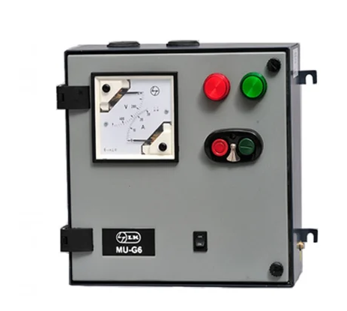  ELEC4784-Electrical-DOL Starter-Single phase  -Manual-L&T MU-2P-CS90319KOTO--Nos | 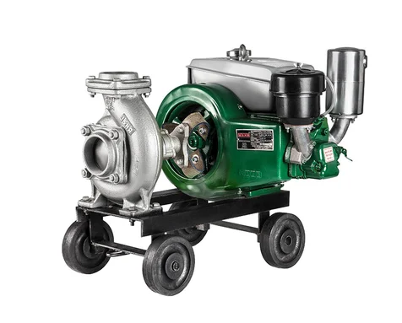  PLUM5838-Plumbing-Diesel Dewatering Pump-Aircooled-VA320-2-4HP-Nos
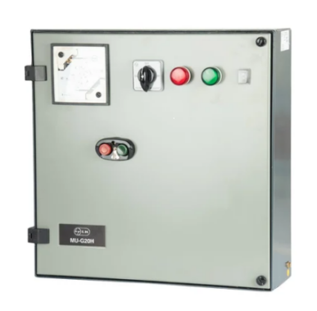  ELEC4446-Electrical-DOL Automatic Starter-Single phase -with dry run protection -L&T-MR-Gi-CS91322NCOG-Nos | 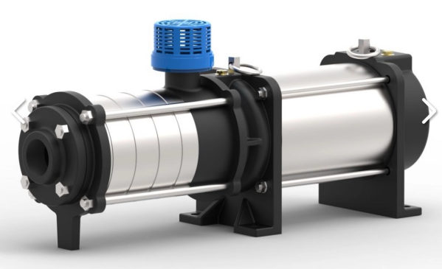  PLUM7052-Plumbing-Openwell Submersible pump-Multi stage-3phase-LHMS-58A-2HP-Nos
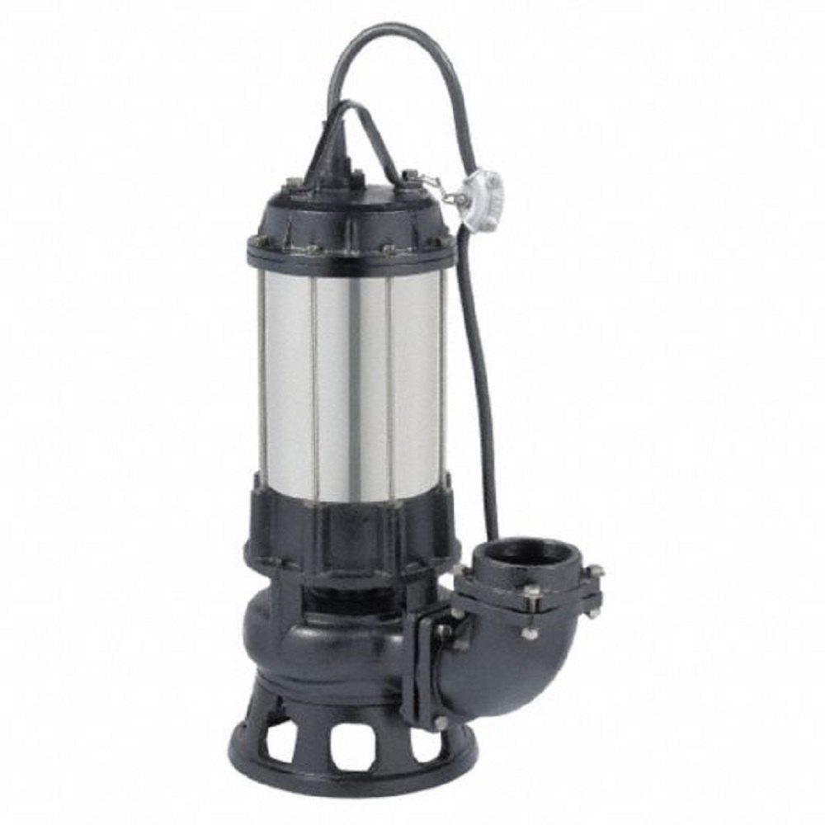  PLUM3642-Plumbing-Dewatering Cutter Pump-CI-Single phase-1300BW-1.75HP-Nos | 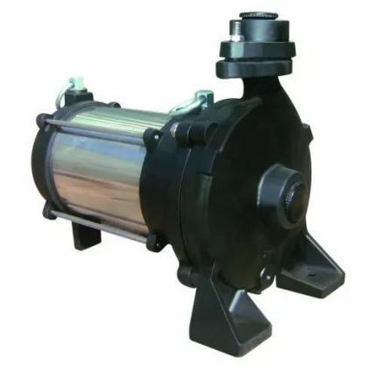  PLUM4887-Plumbing-Openwell Submersible pump-Single phase-KOSI -123M-1HP-Nos
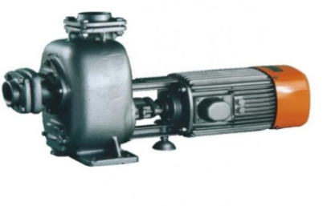PLUM8711-Plumbing-Dewatering self priming mono block pump-Single phase--SP-0M-1HP -Nos | 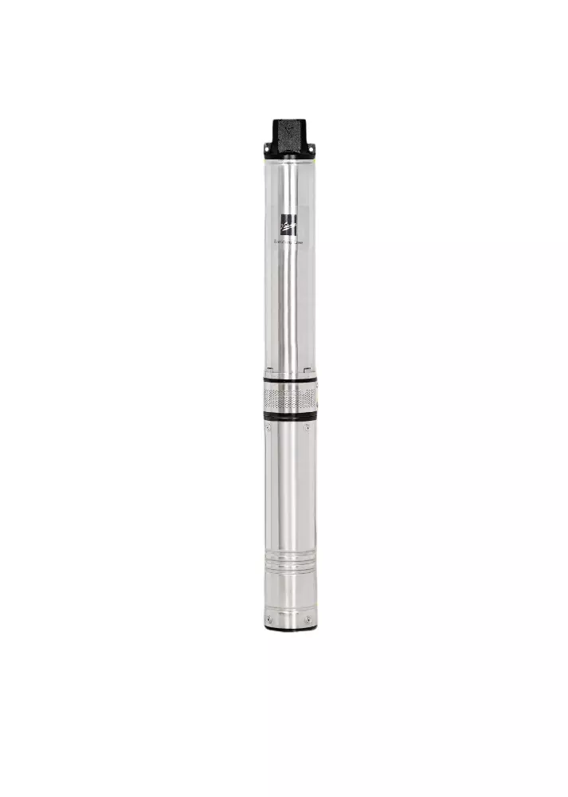  PLUM2616-Plumbing-Borewell Submersible pump-Single phase-CORA 2C/7-0.5HP-Nos
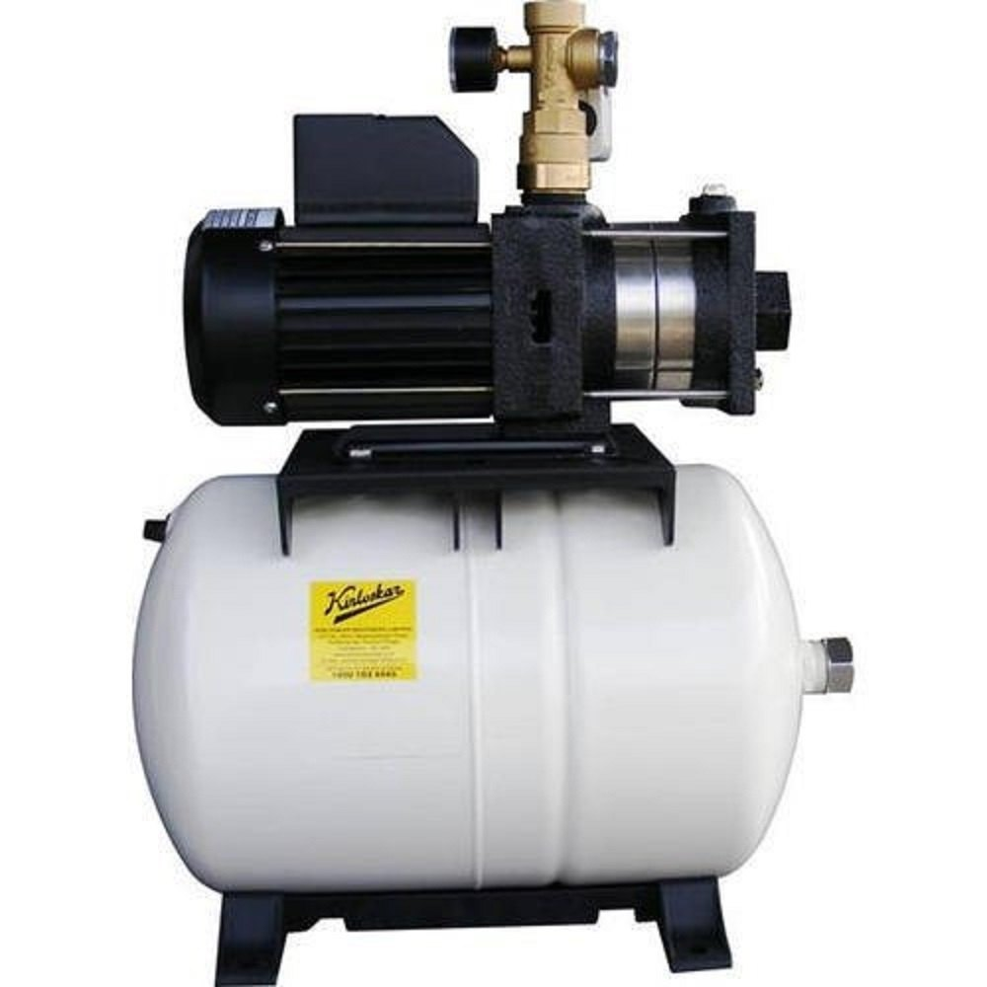  PLUM5517-Plumbing-Pressure Booster pump-Single phase-CPBS-52424H/V-0.6HP-Nos | 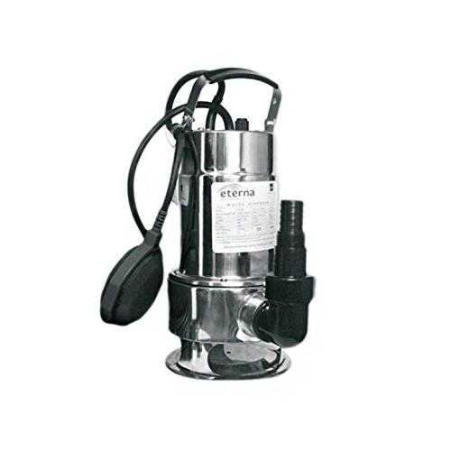  PLUM1594-Plumbing-Dewatering Cutter Pump-SS-Single phase-750SW-1HP-Nos

