Internal Memo no. 912-162 – construction Date: 20-10-2023

Subject: Fire fighting alarm system -Addressable &Non -Addressable
Keywords: Smoke detectors, Manual call points , Hooters , Fire alarm panel, FRLS cable

- Sites to use:Purchase and installation of Addressable &Non Addressable fire fighting alarm system have been standardized . The details are given herein.
Sl.  No. | Description of item | Details of use | SKU no. | Appx. Cost  in Rs.
1. | Addressable multi detector | To detect smoke or heat and designed to work with addressable fire alarm panel. It is to be ordered for lab space project. | FIRE8325-  Fire&Safety -Smoke Detector Addressable  -No’s | 1,650-
2. | Addressable Manual call points | To initiate an alarm signal and operate using a simple button or when glass is broken revealing a button. It is designed to work with addressable fire alarm panel. It is to be ordered for lab space project. | FIRE1057-  Fire&Safety-Manual call point- Addressable-No’s | 2,655/-
3. | Addressable Hooter | It is designed to emit loud and distinct alarm tones to alert occupants of a building during a fire or other emergencies. It is designed to work with addressable fire alarm panel. It is to be ordered | FIRE5585-  Fire&Safety-Hooters- Addressable-No’s | 1,475/-
4. | Addressable Control Module | It receives inputs from various detectors and MCP located in that zone. It is to be ordered for lab space project. | FIRE3099-  Fire&Safety-Control module-Addressable- No’s | 2,566/-
6. | Addressable fire alarm panel | It is a 4 loop panel. These are fire protection systems that are able to swiftly detect and pin point an exact location when trouble arises. It is to be ordered for lab space project. | FIRE3869-Fire&safety  -fire alarm panel 4 loop-No’s | 36,000/-
6. | FRLS cable | Fire resistant cables which are used at locations that are more prone to fire, like in electrical panel room. Also there is no need of conducting this cable. For both Addressable and non addressable will do | FIRE7603-Fire & Safety-Copper Cable-Red-FRLS--2coreX1.5sqm-Bundles | 29,200/-per Bundle(500m)
7. | SMPS | To convert AC to DC, as our devices need DC | COMP7349-  peripherals-SMPS-24v- 3-6A -No’s | 708/-
8. | P clamps | To install FRLS cables | FIRE1616-  Fire&Safety-Cable clamp- P type-15mm- No’s | 3/-

9. | Bosch Fishers | To install FRLS cables, smoke detectors | HARD7695-Hardware- Fischer plug-6mm- Boxes | 194/-per packet(100pcs per packet)
10. | SS Screws Pan head | Used to install FRLS cable and detectors | HARD7590-Hardware- SS Screws Pan head- 8x32mm-Pkts | 153/-per packet- (100pcs per  packet)
11. | Surface Box | To install smoke detectors when it has to be installed directly to ceiling. | ELEC8140- Electrical - PVC Surface box - 2 module-No’s | 41/-
12 | Non- Addressable multi detector | To detect smoke or heat and designed to work with conventional fire alarm panel. Typically used in housing project | FIRE78555-  Fire&Safety-Smoke Detector -Non- Addressable -No’s | 683/-
13 | Non- Addressable Manual call points | Typically installed at fire escape routes and it allows occupants to manually activate the fire alarm system in case of emergency. Typically used in housing project | FIRE7360-  Fire&Safety-Manual call point-Non- Addressable-No’s | 1,734/-
14 | Non- Addressable Hooter | Typically installed at fire escape routes that produces loud noise with a frequency that reaches a large area to alert people regarding any hazardous conditions. Typically used in housing project. | FIRE2644-  Fire&Safety-Hooters- Non-Addressable- No’s | 1,578/-
15 | Non- Addressable fire alarm panel | This system have zones on them, which are basically just circuits. Typically used in housing project. | FIRE2531-Fire & Safety- Fire Alarm Panel- 8Zone- Nos. | 8,496/-
 | Non- Addressable fire alarm panel | This system have zones on them, which are basically just circuits. Typically used in housing project. | FIRE5145-Fire&safety-Fire Alarm panel-4 Zone-Nos. | 11,623
16 | Multi Sensor Detector | It combines multiple sensing technologies in one unit to improve detection accuracy and reduce false alarms. | FIRE1019-Fire& Safety-MultiSensor Detector---Nos. | 1995/-
17 | SingleLoop card-(Addressable) | Enables connection and communication of multiple addressable fire detection devices (smoke detectors, heat detectors, MCPs, sounders, etc.) on a single loop with unique device addressing and monitoring through the fire alarm control panel. | FIRE2205-Fire&safety-SingleLoopcard-Addressable--Nos. | 25,500/-
18 | Monitor module | Used to monitor the status of conventional fire alarm devices and transmit signals to the addressable fire alarm control panel. | FIRE3427-Fire & Safety-Monitor module---Nos. | 2,125/-
19 | Heat Detector | Detects temperature rise and activates fire alarm. | FIRE7431-Fire& Safety-Heat Detector---Nos. | 1775/-
 | Response Indicator | It helps in quick identification of which device has been triggered during a fire or emergency situation. | Fire & Safety-Response Indicator---Nos. | 94/-

Notes:
  - Conventional fire alarm system is followed all housing projects and material ordered shall be of conventional/Non addressable fire alarm
  - Addressable fire alarm system is followed in Lab space projects and it is installed in common areas like lift lobby and central lobby areas . So accordingly addressable type of material should be ordered .
  - Same FRLS cable as mentioned above can be used for both fire alarm systems, cable is erected using ‘P’ type clamps using above fishers and screws and there is no requirement of PVC/Metal conduits for running the cable.

Soham Modi

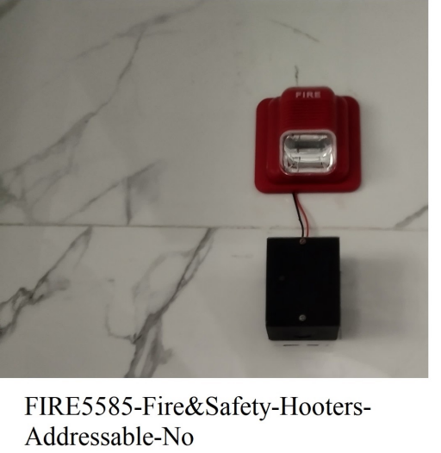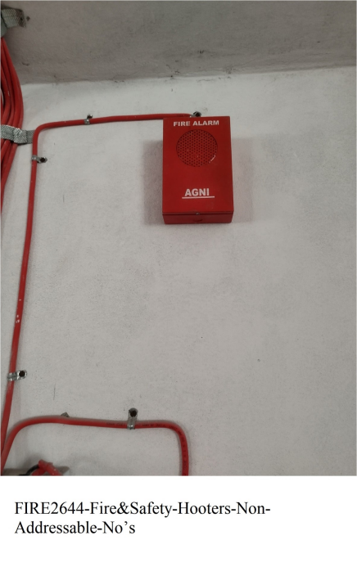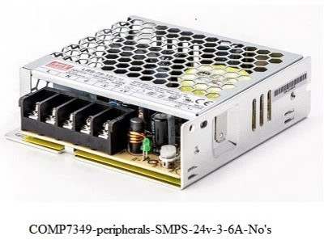
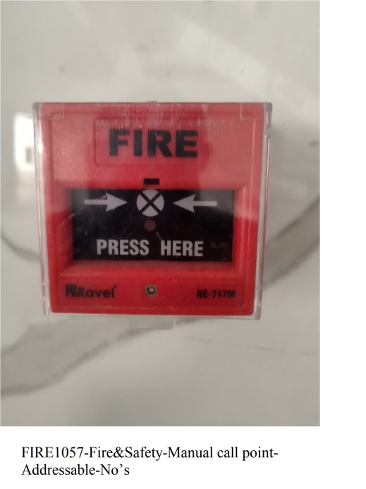
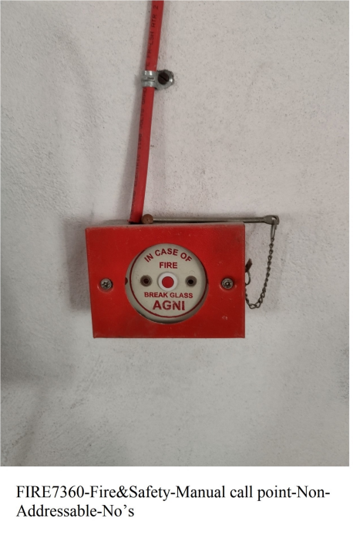
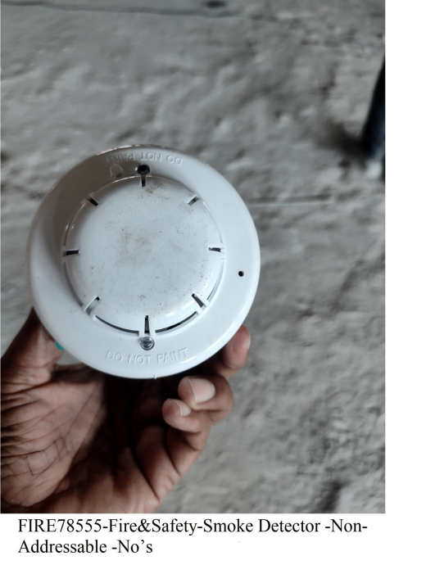
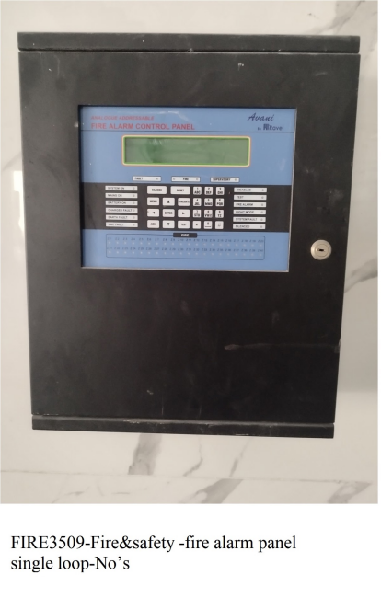
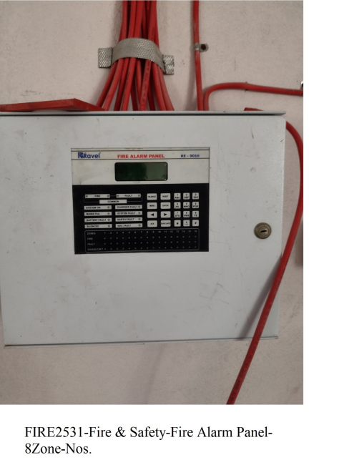
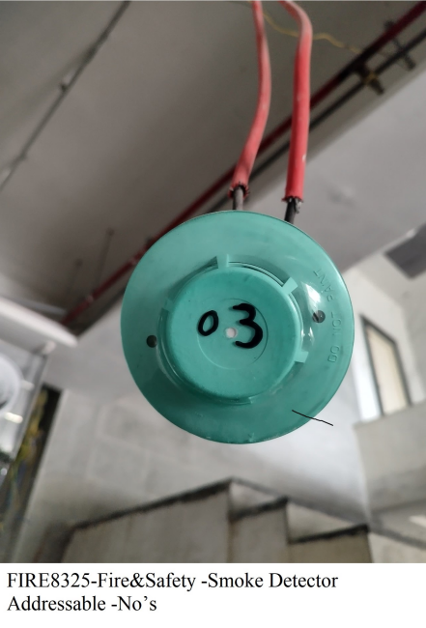

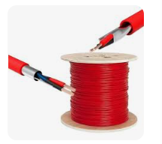
FIRE7603-Fire & Safety-Copper Cable-Red-FRLS--2coreX1.5sqm-Bundles 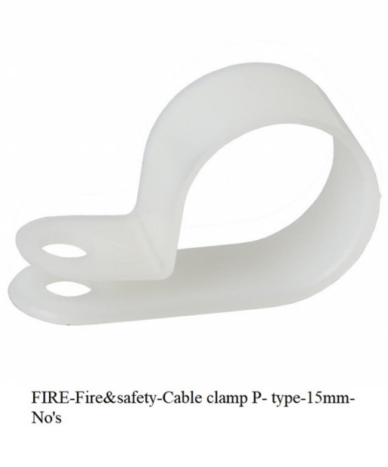 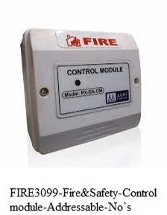

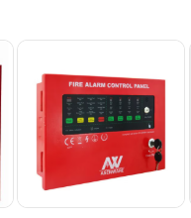
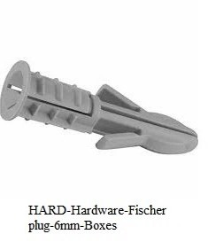
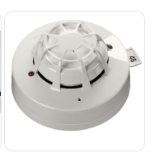
FIRE5145-Fire&safety-Fire Alarm panel-4 Zone-Nos FIRE1019-Fire& Safety-MultiSensor Detector-

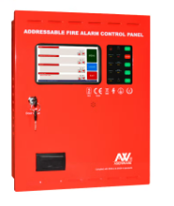
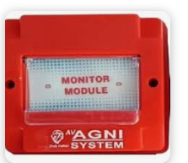

FIRE3427-Fire & Safety-Monitor module---Nos. FIRE2205-Fire&safety-SingleLoopcard-Addressable--Nos

