Name | Methodist Complex
Sale or Lease | Lease only
Location | Abids Main Road, Hyderabad.
 | Opposite Chermas, Next to SBH Gunfoundary.
Area | II floor - Office no. 203 - 1,485 sft
Lease | · Rs. 20 per sft
 | · Property Tax to be paid by the Lessor.
 | · 6 months rent as interest free deposit.
 | · Rent increase by 6% every year.
 | · Maintenance Rs. 2.00 per sft.
 | · | Electricity charges extra.
Remarks | · Well known Shopping Complex.
 | · Ideal for banks, corporate offices, training institutes, etc.
 | · | Ample Parking.
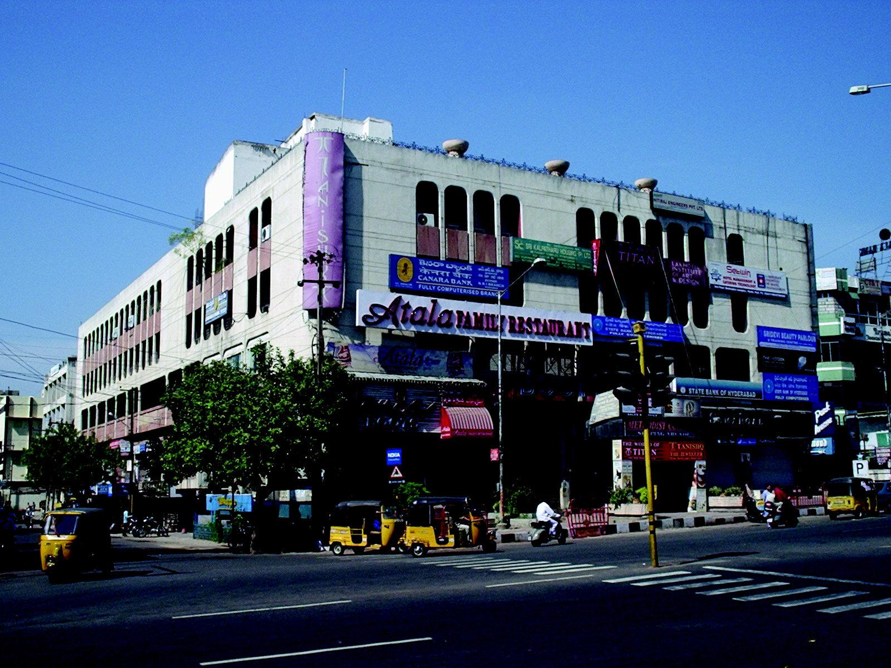

FLOOR PLAN GIVEN OVER LEAF

Modi Consultancy Services.
Call: Anand Kumar Netha +91-9502277099
Email: anandkumar@modiproperties.com, www.modiconsultancyservices.com
mbmc.3rd floor.office.writeup. ver 4.dt.26.06.2020.doc

