Name | Methodist Complex
Sale or Lease | Lease only
Location | Abids Main Road, Hyderabad.
 | Opposite Chermas, Next to SBH Gunfoundary.
Area | III floor: Office no. 304 – 1,445 sft
Lease | · Rs. 20 per sft
 | · Property Tax to be paid by the Lessor.
 | · 6 months rent as interest free deposit.
 | · Rent increase by 6% every year.
 | · Maintenance Rs. 2.00 per sft.
 | · | Electricity charges extra.
Remarks | · Well known Shopping Complex.
 | · Ideal for banks, corporate offices, training institutes, etc.
 | · | Ample Parking.
 | · Option of warm shell or plug & play at additional cost.
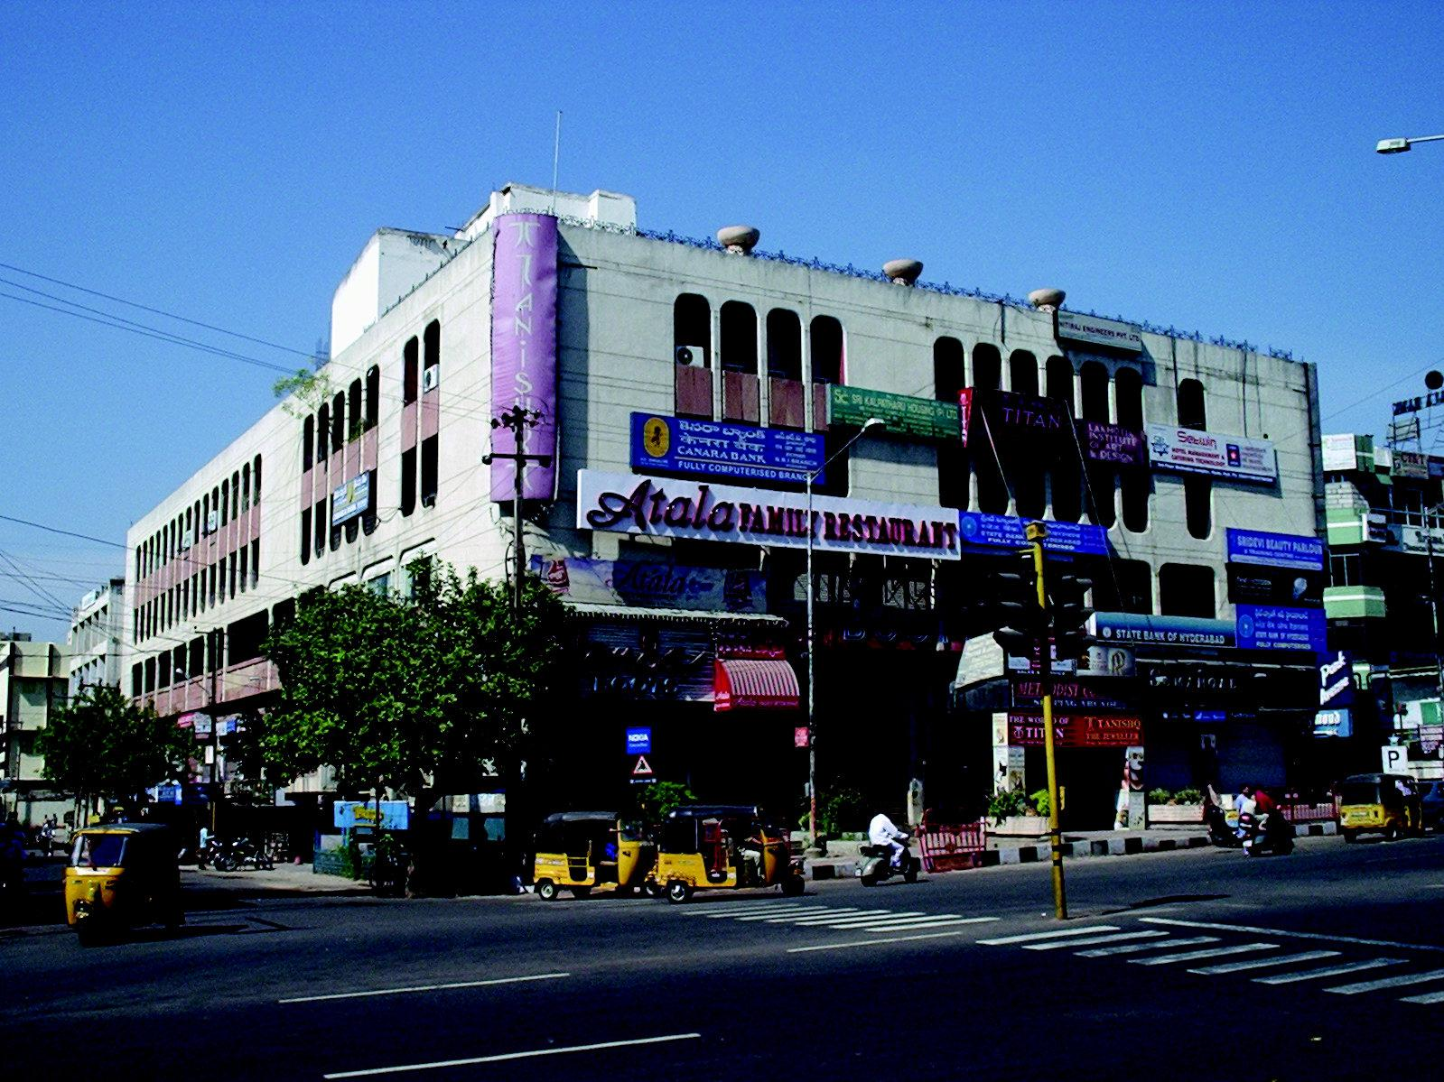

FLOOR PLAN GIVEN OVER LEAF

Modi Consultancy Services.
Call: Anand Kumar Netha +91-9502277099
Email: anandkumar@modiproperties.com, www.modiconsultancyservices.com
Mbmc III floor writeup dt 26.06.2020
