Name | Methodist Complex
Sale or Lease | Lease only
Location | Abids Main Road, Hyderabad.  Opposite Chermas, Next to SBH Gunfoundary.
Area | IV floor: 11,100 sft + open terrace of about 2,500 sft
Lease | - Rs. 20 per sft  - Property Tax to be paid by the Lessor.  - 6 months rent as interest free deposit.  - Rent increase by 6% every year.  - Maintenance Rs. 1.50/- per sft.  - Electricity charges extra.
Remarks | - Well known Shopping Complex.  - Ideal for banquet hall, training institutes & corporate offices.  - Exclusive floor.  - 2 lifts  - Ample Parking.

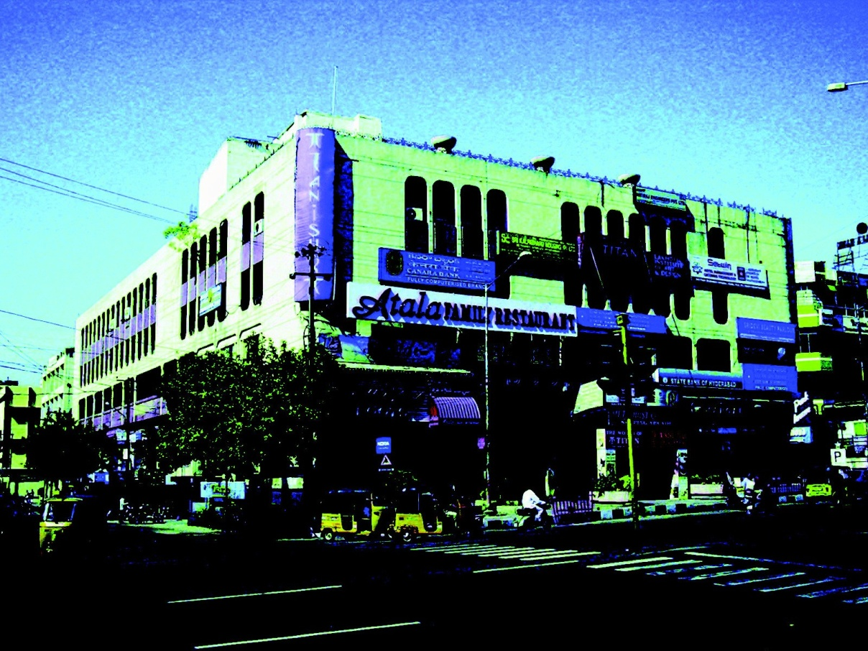

FLOOR PLAN GIVEN OVER LEAF

Modi Consultancy Services.
Call: Anand Kumar Netha +91-9502277099
Email: anandkumar@modiproperties.com, www.modiconsultancyservices.com
Mbmc.IV floor.office.rental Write up ver3 dt 26.06.2020.doc

