Name | Modi Complex
Sale or Lease | Lease only
Location | Necklace Road, Karbala Maidan, Secunderabad.  Complex having access from M. G. Road and Necklace Road. Next to Justa Hotels & Moksh Banquets.
Area | First Floor: 11,000 sft  Reserve parking space of 3,500 sft in basement | First Floor: 4,500 sft.
Terms of Lease | - Rs. 30 per sft.  - Property Tax to be paid by Lessor.  - 6 months rent as interest free deposit.  - Rent increase by 7% every year.  - Maintenance Rs. 2.50/- per sft.  - Electricity charges extra. | - Rs. 30 per sft.  - Property Tax to be paid by Lessor.  - 6 months rent as interest free deposit.  - Rent increase by 7% every year.  - Maintenance Rs. 2.50/- per sft.  - Electricity charges extra
Features | - Premises will be renovated within 8 weeks of confirmation.  - Vitrified floor tiles with zypsum false ceiling shall be provided.  - Bathrooms will be fully renovated.  - Fresh coat of paint shall be done. | - Fully furnished.  - Minor refurbishing of furniture shall be taken up as per requirement.
Remarks | - Building faces Necklace Road.  - Ample common parking area around the building.  - Lobby on ground and first floor shall be renovated and flooring replaced with granite on confirmation of lease.

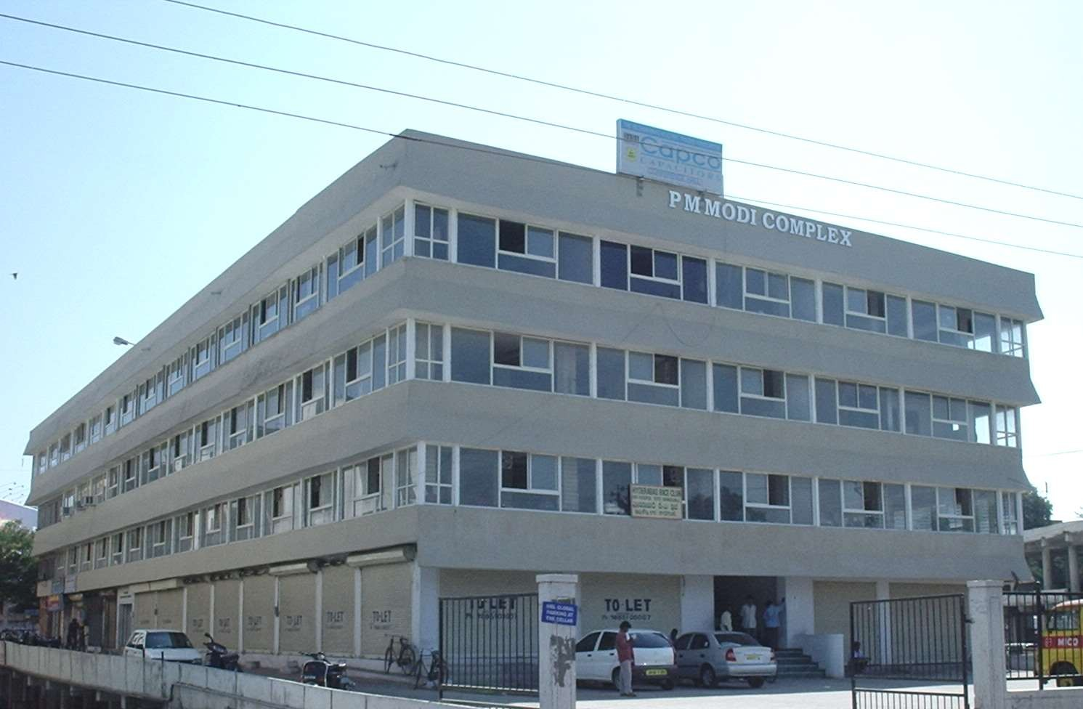

FLOOR PLAN GIVEN OVERLEAF

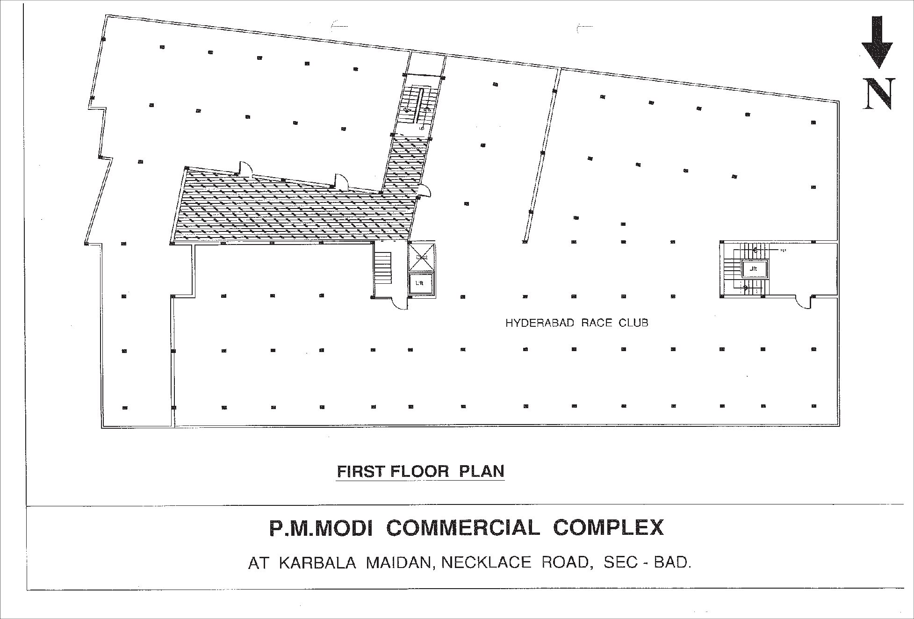

4,500 sft

11000 sft

